UNITED STATES
SECURITIES AND EXCHANGE COMMISSION
Washington, D.C. 20549
FORM 8-K

CURRENT REPORT
Pursuant to Section 13 or 15(d) of the Securities Exchange Act of 1934

Date of Report (date of earliest event reported): August 5, 2026

SLM CORPORATION
(Exact name of registrant as specified in its charter)
Delaware |  |  | 001-13251 |  |  |  |  |  | 52-2013874
(State or other jurisdiction of incorporation or organization) |  |  | (Commission File Number) |  |  |  |  |  | (I.R.S. Employer Identification No.)
300 Continental Drive |  |  | Newark, |  |  | Delaware |  |  | 19713
(Address of principal executive offices) |  |  |  |  |  |  |  |  | (Zip Code)

Registrant's telephone number, including area code: (302) 451-4911
(Former name or former address, if changed since last report)

Securities registered pursuant to Section 12(b) of the Act:
Title of each class |  |  | Trading Symbol(s) |  |  | Name of each exchange on which registered
Common stock, par value $.20 per share |  |  | SLM |  |  | The NASDAQ Global Select Market
Floating Rate Non-Cumulative Preferred Stock, Series B, par value $.20 per share |  |  | SLMBP |  |  | The NASDAQ Global Select Market

Check the appropriate box below if the Form 8-K filing is intended to simultaneously satisfy the filing obligation of the registrant under any of the following provisions:

☐ Written communications pursuant to Rule 425 under the Securities Act (17 CFR 230.425)

☐ Soliciting material pursuant to Rule 14a-12 under the Exchange Act (17 CFR 240.14a-12)

☐ Pre-commencement communications pursuant to Rule 14d-2(b) under the Exchange Act (17 CFR 240.14d-2(b))

☐ Pre-commencement communications pursuant to Rule 13e-4(c) under the Exchange Act (17 CFR 240.13e-4(c))

Indicate by check mark whether the registrant is an emerging growth company as defined in Rule 405 of the Securities Act of 1933 (§230.405 of this chapter) or Rule 12b-2 of the Securities Exchange Act of 1934 (§240.12b-2 of this chapter).
Emerging growth company ☐

If an emerging growth company, indicate by check mark if the registrant has elected not to use the extended transition period for complying with any new or revised financial accounting standards provided pursuant to Section 13(a) of the Exchange Act. ☐

ITEM 7.01 REGULATION FD DISCLOSURE.

SLM Corporation (the “Company”) frequently provides relevant information to its investors via posting to its corporate website. On or about August 5, 2026, a presentation entitled “SLM Corporation Investor Presentation as of June 30, 2026” was posted on the Company's website at https://www.salliemae.com/investors/webcasts-and-presentations/ and is furnished herewith as Exhibit 99.1.

The information in this Item 7.01, including Exhibit 99.1 attached hereto and incorporated by reference herein, is being furnished and shall not be deemed "filed" for purposes of Section 18 of the Securities Exchange Act of 1934, as amended, or otherwise subject to the liabilities of that Section. Furthermore, such information, including such Exhibit, shall not be deemed incorporated by reference into any of the Company’s registration statements, reports, or other filings with the Securities and Exchange Commission, except as expressly set forth by specific reference in such registration statement, report, or other filing.

ITEM 9.01 FINANCIAL STATEMENTS AND EXHIBITS.

(d) Exhibits
Exhibit  Number |  |  |  |  |  | Description
99.1* |  |  |  |  |  | SLM Corporation Investor Presentation as of June 30, 2026
104 |  |  |  |  |  | Cover Page Interactive Data File (formatted as Inline XBRL)
* |  |  | Furnished herewith.

SIGNATURES

Pursuant to the requirements of the Securities Exchange Act of 1934, the registrant has duly caused this report to be signed on its behalf by the undersigned hereunto duly authorized.

 |  |  |  |  |  | SLM CORPORATION
Date: August 5, 2026 |  |  | By: |  |  | /s/ PETER M. GRAHAM
 |  |  |  |  |  | Peter M. Graham
 |  |  |  |  |  | Co-President and Chief Financial Officer

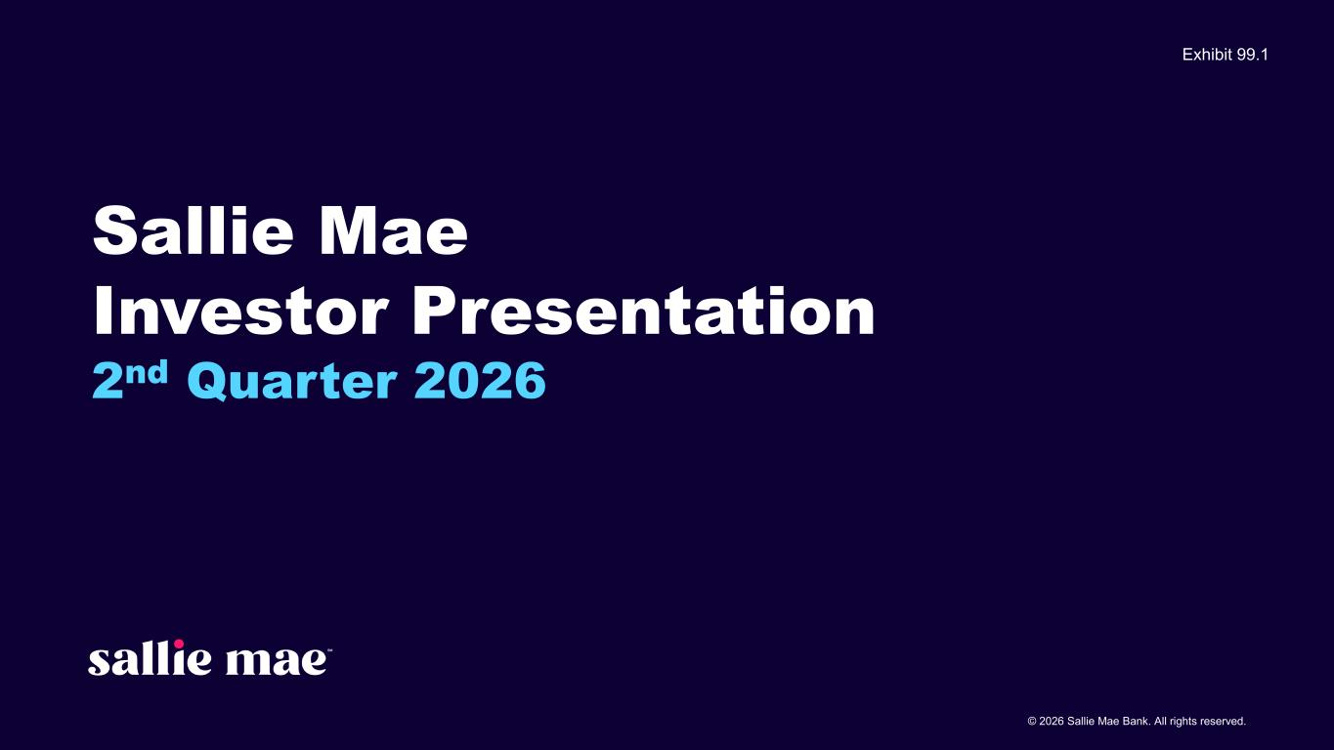

© 2026 Sallie Mae Bank. All rights reserved. Sallie Mae Investor Presentation 2nd Quarter 2026 Exhibit 99.1

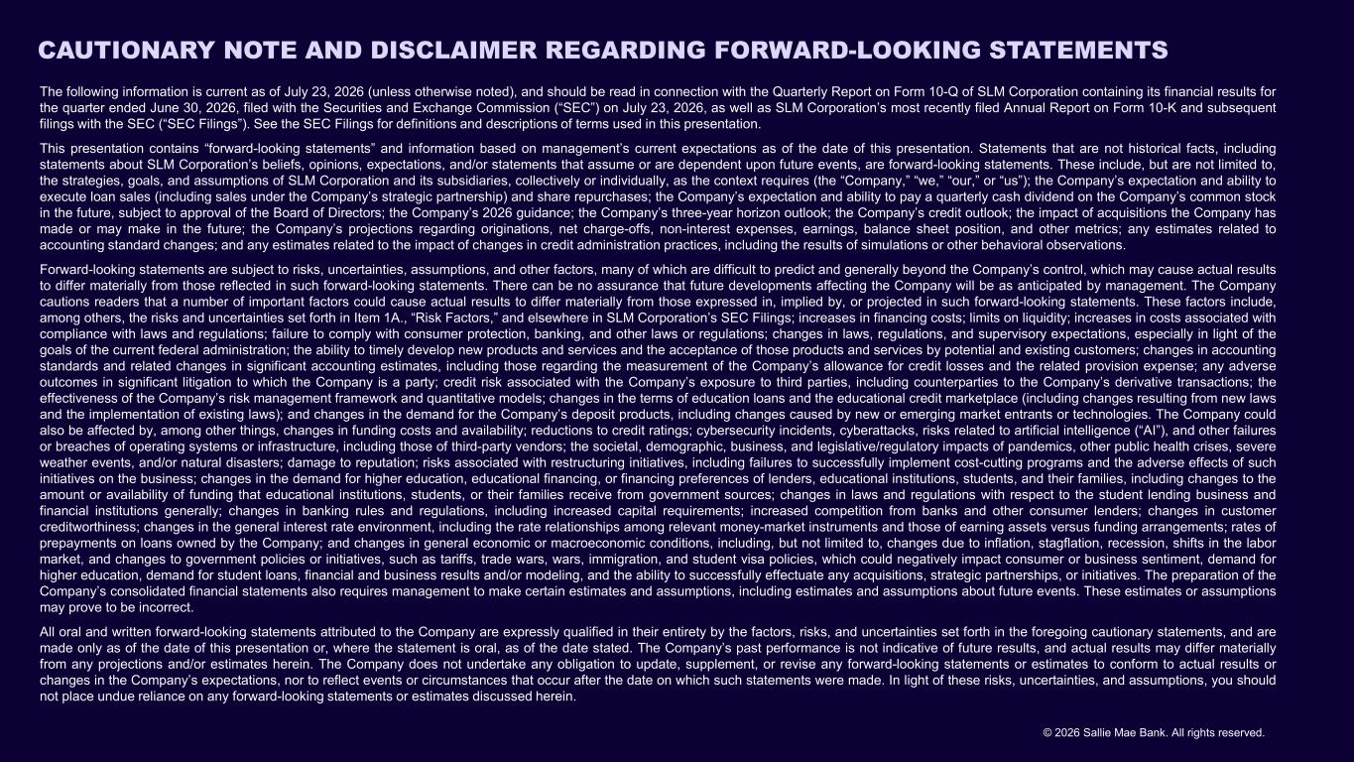
© 2026 Sallie Mae Bank. All rights reserved. CAUTIONARY NOTE AND DISCLAIMER REGARDING FORWARD-LOOKING STATEMENTS The following information is current as of July 23, 2026 (unless otherwise noted), and should be read in connection with the Quarterly Report on Form 10-Q of SLM Corporation containing its financial results for the quarter ended June 30, 2026, filed with the Securities and Exchange Commission (“SEC”) on July 23, 2026, as well as SLM Corporation’s most recently filed Annual Report on Form 10-K and subsequent filings with the SEC (“SEC Filings”). See the SEC Filings for definitions and descriptions of terms used in this presentation. This presentation contains “forward-looking statements” and information based on management’s current expectations as of the date of this presentation. Statements that are not historical facts, including statements about SLM Corporation’s beliefs, opinions, expectations, and/or statements that assume or are dependent upon future events, are forward-looking statements. These include, but are not limited to, the strategies, goals, and assumptions of SLM Corporation and its subsidiaries, collectively or individually, as the context requires (the “Company,” “we,” “our,” or “us”); the Company’s expectation and ability to execute loan sales (including sales under the Company’s strategic partnership) and share repurchases; the Company’s expectation and ability to pay a quarterly cash dividend on the Company’s common stock in the future, subject to approval of the Board of Directors; the Company’s 2026 guidance; the Company’s three-year horizon outlook; the Company’s credit outlook; the impact of acquisitions the Company has made or may make in the future; the Company’s projections regarding originations, net charge-offs, non-interest expenses, earnings, balance sheet position, and other metrics; any estimates related to accounting standard changes; and any estimates related to the impact of changes in credit administration practices, including the results of simulations or other behavioral observations. Forward-looking statements are subject to risks, uncertainties, assumptions, and other factors, many of which are difficult to predict and generally beyond the Company’s control, which may cause actual results to differ materially from those reflected in such forward-looking statements. There can be no assurance that future developments affecting the Company will be as anticipated by management. The Company cautions readers that a number of important factors could cause actual results to differ materially from those expressed in, implied by, or projected in such forward-looking statements. These factors include, among others, the risks and uncertainties set forth in Item 1A., “Risk Factors,” and elsewhere in SLM Corporation’s SEC Filings; increases in financing costs; limits on liquidity; increases in costs associated with compliance with laws and regulations; failure to comply with consumer protection, banking, and other laws or regulations; changes in laws, regulations, and supervisory expectations, especially in light of the goals of the current federal administration; the ability to timely develop new products and services and the acceptance of those products and services by potential and existing customers; changes in accounting standards and related changes in significant accounting estimates, including those regarding the measurement of the Company’s allowance for credit losses and the related provision expense; any adverse outcomes in significant litigation to which the Company is a party; credit risk associated with the Company’s exposure to third parties, including counterparties to the Company’s derivative transactions; the effectiveness of the Company’s risk management framework and quantitative models; changes in the terms of education loans and the educational credit marketplace (including changes resulting from new laws and the implementation of existing laws); and changes in the demand for the Company’s deposit products, including changes caused by new or emerging market entrants or technologies. The Company could also be affected by, among other things, changes in funding costs and availability; reductions to credit ratings; cybersecurity incidents, cyberattacks, risks related to artificial intelligence (“AI”), and other failures or breaches of operating systems or infrastructure, including those of third-party vendors; the societal, demographic, business, and legislative/regulatory impacts of pandemics, other public health crises, severe weather events, and/or natural disasters; damage to reputation; risks associated with restructuring initiatives, including failures to successfully implement cost-cutting programs and the adverse effects of such initiatives on the business; changes in the demand for higher education, educational financing, or financing preferences of lenders, educational institutions, students, and their families, including changes to the amount or availability of funding that educational institutions, students, or their families receive from government sources; changes in laws and regulations with respect to the student lending business and financial institutions generally; changes in banking rules and regulations, including increased capital requirements; increased competition from banks and other consumer lenders; changes in customer creditworthiness; changes in the general interest rate environment, including the rate relationships among relevant money-market instruments and those of earning assets versus funding arrangements; rates of prepayments on loans owned by the Company; and changes in general economic or macroeconomic conditions, including, but not limited to, changes due to inflation, stagflation, recession, shifts in the labor market, and changes to government policies or initiatives, such as tariffs, trade wars, wars, immigration, and student visa policies, which could negatively impact consumer or business sentiment, demand for higher education, demand for student loans, financial and business results and/or modeling, and the ability to successfully effectuate any acquisitions, strategic partnerships, or initiatives. The preparation of the Company’s consolidated financial statements also requires management to make certain estimates and assumptions, including estimates and assumptions about future events. These estimates or assumptions may prove to be incorrect. All oral and written forward-looking statements attributed to the Company are expressly qualified in their entirety by the factors, risks, and uncertainties set forth in the foregoing cautionary statements, and are made only as of the date of this presentation or, where the statement is oral, as of the date stated. The Company’s past performance is not indicative of future results, and actual results may differ materially from any projections and/or estimates herein. The Company does not undertake any obligation to update, supplement, or revise any forward-looking statements or estimates to conform to actual results or changes in the Company’s expectations, nor to reflect events or circumstances that occur after the date on which such statements were made. In light of these risks, uncertainties, and assumptions, you should not place undue reliance on any forward-looking statements or estimates discussed herein.

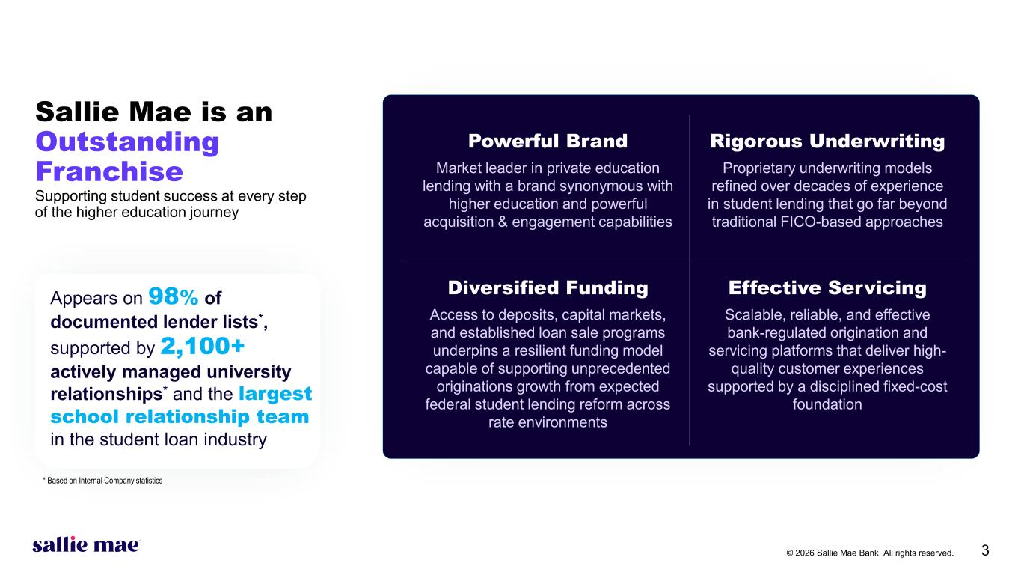
© 2026 Sallie Mae Bank. All rights reserved. 3 Powerful Brand Rigorous Underwriting Market leader in private education lending with a brand synonymous with higher education and powerful acquisition & engagement capabilities Proprietary underwriting models refined over decades of experience in student lending that go far beyond traditional FICO-based approaches Diversified Funding Effective Servicing Access to deposits, capital markets, and established loan sale programs underpins a resilient funding model capable of supporting unprecedented originations growth from expected federal student lending reform across rate environments Scalable, reliable, and effective bank-regulated origination and servicing platforms that deliver high- quality customer experiences supported by a disciplined fixed-cost foundation Sallie Mae is an Outstanding Franchise Supporting student success at every step of the higher education journey Appears on 98% of documented lender lists*, supported by 2,100+ actively managed university relationships* and the largest school relationship team in the student loan industry * Based on Internal Company statistics

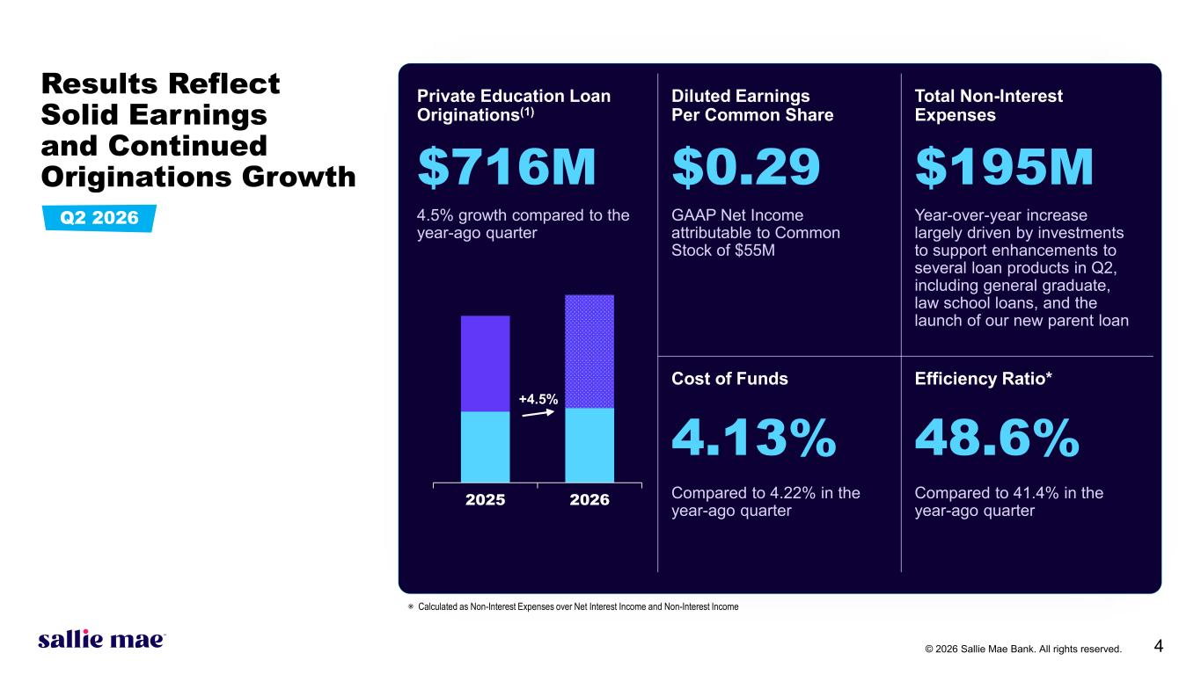
© 2026 Sallie Mae Bank. All rights reserved. 4 Results Reflect Solid Earnings and Continued Originations Growth Private Education Loan Originations(1) Diluted Earnings Per Common Share Total Non-Interest Expenses $716M $0.29 $195M 4.5% growth compared to the year-ago quarter GAAP Net Income attributable to Common Stock of $55M Year-over-year increase largely driven by investments to support enhancements to several loan products in Q2, including general graduate, law school loans, and the launch of our new parent loan Cost of Funds Efficiency Ratio* 4.13% 48.6% Compared to 4.22% in the year-ago quarter Compared to 41.4% in the year-ago quarter2025 2026 +4.5% Q2 2026 ⁕ Calculated as Non-Interest Expenses over Net Interest Income and Non-Interest Income

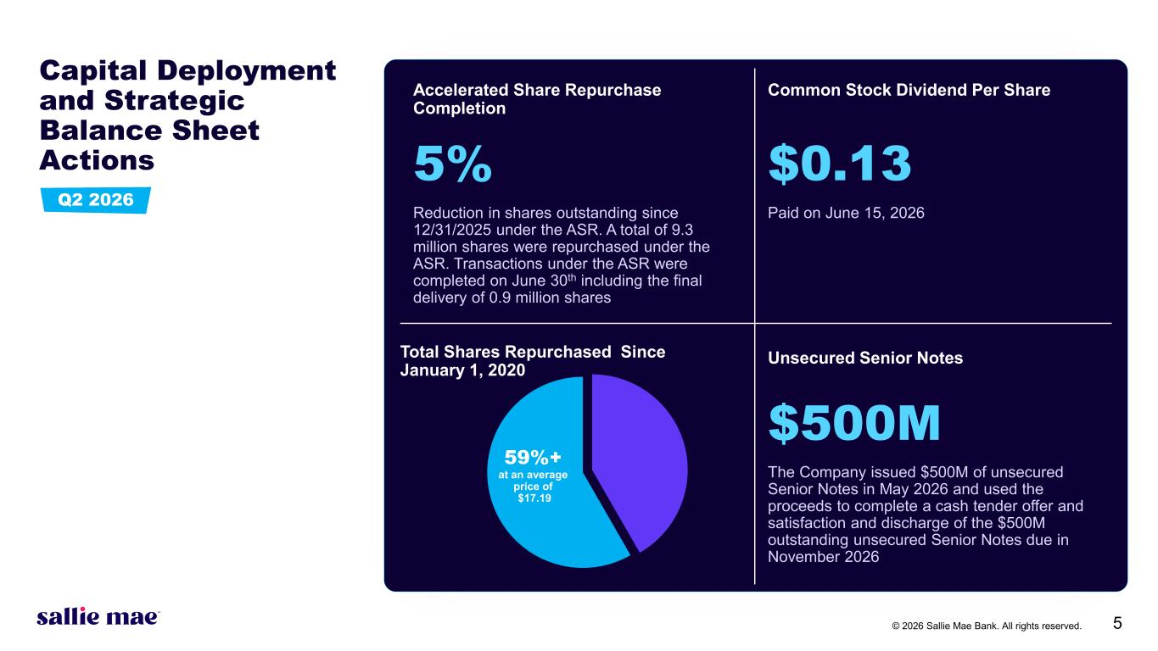
© 2026 Sallie Mae Bank. All rights reserved. 5 Capital Deployment and Strategic Balance Sheet Actions 58%+ at an average price of $17.15 Accelerated Share Repurchase Completion Common Stock Dividend Per Share 5% $0.13 Reduction in shares outstanding since 12/31/2025 under the ASR. A total of 9.3 million shares were repurchased under the ASR. Transactions under the ASR were completed on June 30th including the final delivery of 0.9 million shares Paid on June 15, 2026 Total Shares Repurchased Since January 1, 2020 Unsecured Senior Notes $500M The Company issued $500M of unsecured Senior Notes in May 2026 and used the proceeds to complete a cash tender offer and satisfaction and discharge of the $500M outstanding unsecured Senior Notes due in November 2026 59%+ at an average price of $17.19 Q2 2026

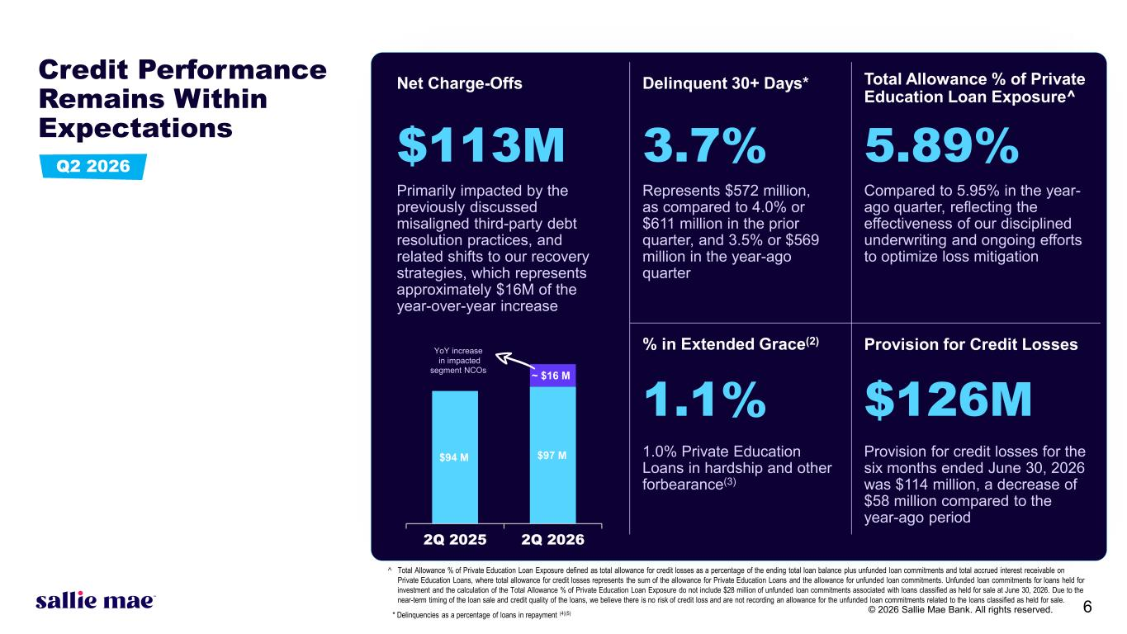
© 2026 Sallie Mae Bank. All rights reserved. 6 Net Charge-Offs Delinquent 30+ Days* Total Allowance % of Private Education Loan Exposure^ $113M 3.7% 5.89% Primarily impacted by the previously discussed misaligned third-party debt resolution practices, and related shifts to our recovery strategies, which represents approximately $16M of the year-over-year increase Represents $572 million, as compared to 4.0% or $611 million in the prior quarter, and 3.5% or $569 million in the year-ago quarter Compared to 5.95% in the year- ago quarter, reflecting the effectiveness of our disciplined underwriting and ongoing efforts to optimize loss mitigation % in Extended Grace(2) Provision for Credit Losses 1.1% $126M 1.0% Private Education Loans in hardship and other forbearance(3) Provision for credit losses for the six months ended June 30, 2026 was $114 million, a decrease of $58 million compared to the year-ago period Credit Performance Remains Within Expectations Q2 2026 * Delinquencies as a percentage of loans in repayment (4)(5) ^ Total Allowance % of Private Education Loan Exposure defined as total allowance for credit losses as a percentage of the ending total loan balance plus unfunded loan commitments and total accrued interest receivable on Private Education Loans, where total allowance for credit losses represents the sum of the allowance for Private Education Loans and the allowance for unfunded loan commitments. Unfunded loan commitments for loans held for investment and the calculation of the Total Allowance % of Private Education Loan Exposure do not include $28 million of unfunded loan commitments associated with loans classified as held for sale at June 30, 2026. Due to the near-term timing of the loan sale and credit quality of the loans, we believe there is no risk of credit loss and are not recording an allowance for the unfunded loan commitments related to the loans classified as held for sale. $94 M $97 M ~ $16 M 2Q 2025 2Q 2026 YoY increase in impacted segment NCOs

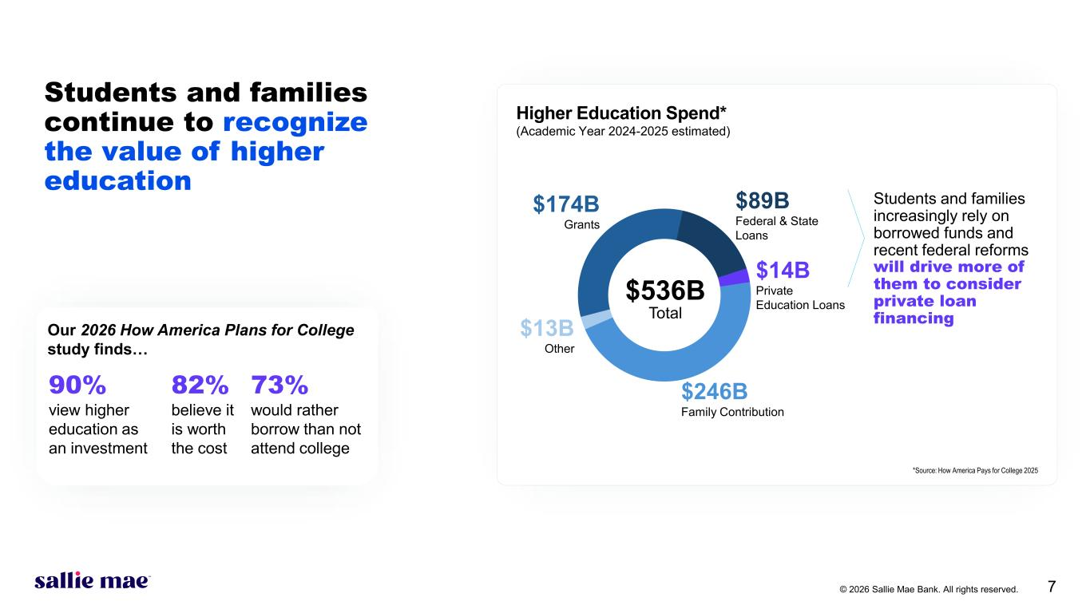
© 2026 Sallie Mae Bank. All rights reserved. 7 46% Family Contribution 32% Grants Students and families increasingly rely on borrowed funds and recent federal reforms will drive more of them to consider private loan financing Our 2026 How America Plans for College study finds… Higher Education Spend* (Academic Year 2024-2025 estimated) 90% 82% 73% view higher education as an investment believe it is worth the cost would rather borrow than not attend college *Source: How America Pays for College 2025 Students and families continue to recognize the value of higher education $246B Family Contribution $174B Grants $13B Other $14B Private Education Loans $89B Federal & State Loans $536B Total

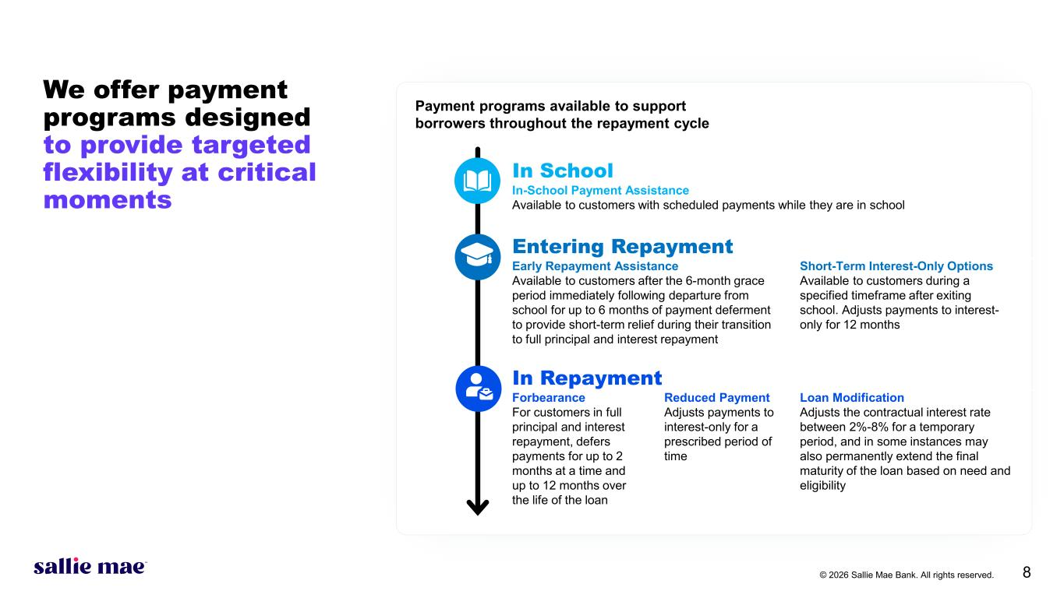
© 2026 Sallie Mae Bank. All rights reserved. 8 We offer payment programs designed to provide targeted flexibility at critical moments Payment programs available to support borrowers throughout the repayment cycle In School In-School Payment Assistance Available to customers with scheduled payments while they are in school Entering Repayment Early Repayment Assistance Available to customers after the 6-month grace period immediately following departure from school for up to 6 months of payment deferment to provide short-term relief during their transition to full principal and interest repayment Short-Term Interest-Only Options Available to customers during a specified timeframe after exiting school. Adjusts payments to interest- only for 12 months In Repayment Forbearance For customers in full principal and interest repayment, defers payments for up to 2 months at a time and up to 12 months over the life of the loan Reduced Payment Adjusts payments to interest-only for a prescribed period of time Loan Modification Adjusts the contractual interest rate between 2%-8% for a temporary period, and in some instances may also permanently extend the final maturity of the loan based on need and eligibility

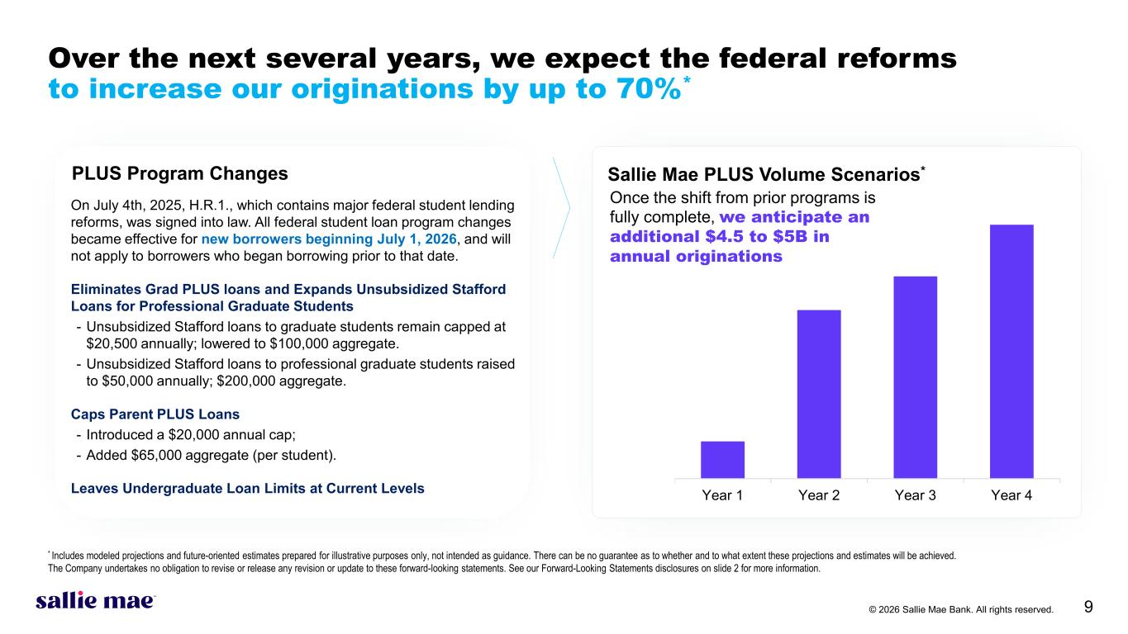
© 2026 Sallie Mae Bank. All rights reserved. 9 * Includes modeled projections and future-oriented estimates prepared for illustrative purposes only, not intended as guidance. There can be no guarantee as to whether and to what extent these projections and estimates will be achieved. The Company undertakes no obligation to revise or release any revision or update to these forward-looking statements. See our Forward-Looking Statements disclosures on slide 2 for more information. On July 4th, 2025, H.R.1., which contains major federal student lending reforms, was signed into law. All federal student loan program changes became effective for new borrowers beginning July 1, 2026, and will not apply to borrowers who began borrowing prior to that date. Eliminates Grad PLUS loans and Expands Unsubsidized Stafford Loans for Professional Graduate Students - Unsubsidized Stafford loans to graduate students remain capped at $20,500 annually; lowered to $100,000 aggregate. - Unsubsidized Stafford loans to professional graduate students raised to $50,000 annually; $200,000 aggregate. Caps Parent PLUS Loans - Introduced a $20,000 annual cap; - Added $65,000 aggregate (per student). Leaves Undergraduate Loan Limits at Current Levels PLUS Program Changes Year 1 Year 2 Year 3 Year 4 Once the shift from prior programs is fully complete, we anticipate an additional $4.5 to $5B in annual originations Sallie Mae PLUS Volume Scenarios* Over the next several years, we expect the federal reforms to increase our originations by up to 70%*

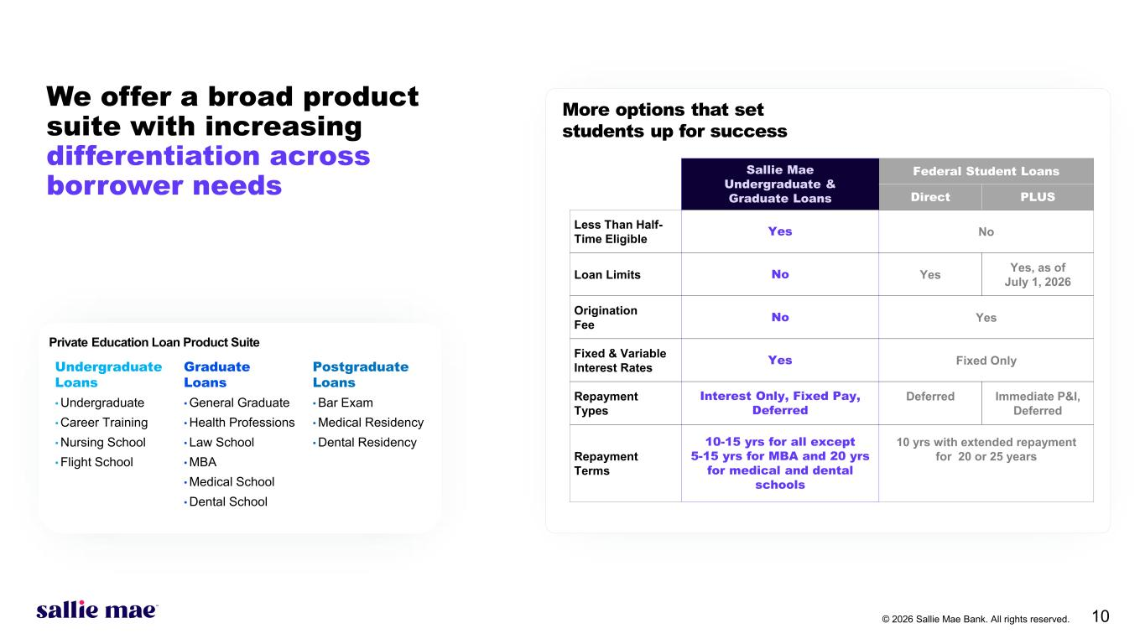
© 2026 Sallie Mae Bank. All rights reserved. 10 We offer a broad product suite with increasing differentiation across borrower needs Undergraduate Loans Graduate Loans Postgraduate Loans • Undergraduate • Career Training • Nursing School • Flight School • General Graduate • Health Professions • Law School • MBA • Medical School • Dental School • Bar Exam • Medical Residency • Dental Residency Private Education Loan Product Suite Sallie Mae Undergraduate & Graduate Loans Federal Student Loans Direct PLUS Less Than Half- Time Eligible Yes No Loan Limits No Yes Yes, as of July 1, 2026 Origination Fee No Yes Fixed & Variable Interest Rates Yes Fixed Only Repayment Types Interest Only, Fixed Pay, Deferred Deferred Immediate P&I, Deferred Repayment Terms 10-15 yrs for all except 5-15 yrs for MBA and 20 yrs for medical and dental schools 10 yrs with extended repayment for 20 or 25 years More options that set students up for success

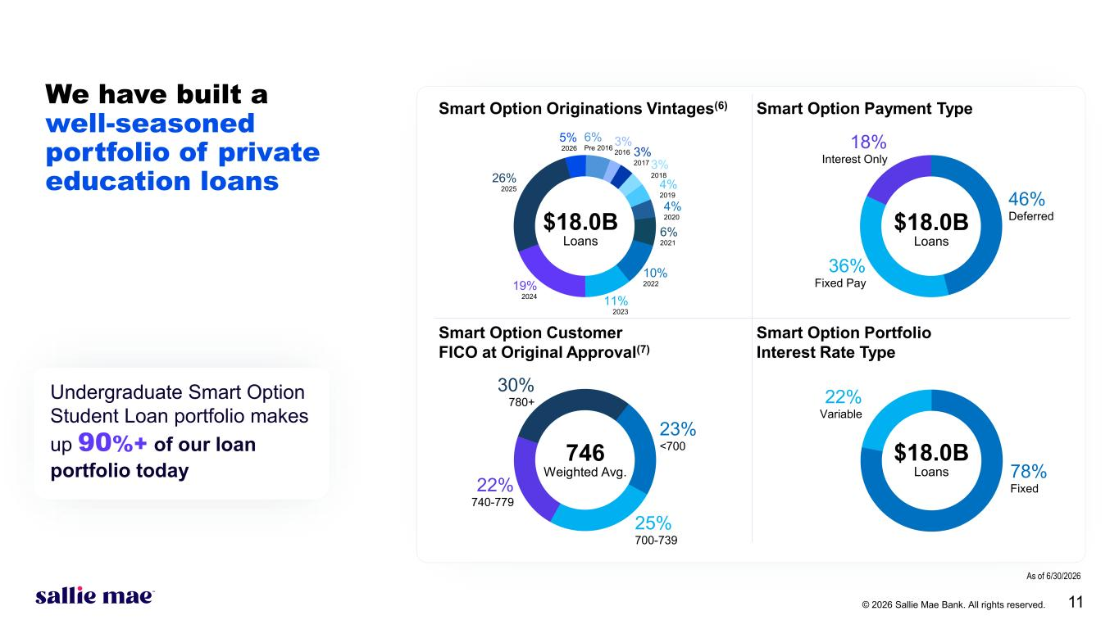
© 2026 Sallie Mae Bank. All rights reserved. 11 We have built a well-seasoned portfolio of private education loans Smart Option Originations Vintages(6) Smart Option Payment Type Smart Option Customer FICO at Original Approval(7) Smart Option Portfolio Interest Rate Type Undergraduate Smart Option Student Loan portfolio makes up 90%+ of our loan portfolio today 22% Variable 46% Deferred 36% Fixed Pay 18% Interest Only 30% 780+ 23% <700 25% 700-739 22% 740-779 26% 2025 6% Pre 2016 3% 2016 3% 2017 3% 2018 4% 2019 4% 2020 6% 2021 10% 2022 11% 2023 19% 2024 5% 2026 746 Weighted Avg. $18.0B Loans $18.0B Loans $18.0B Loans 78% Fixed As of 6/30/2026

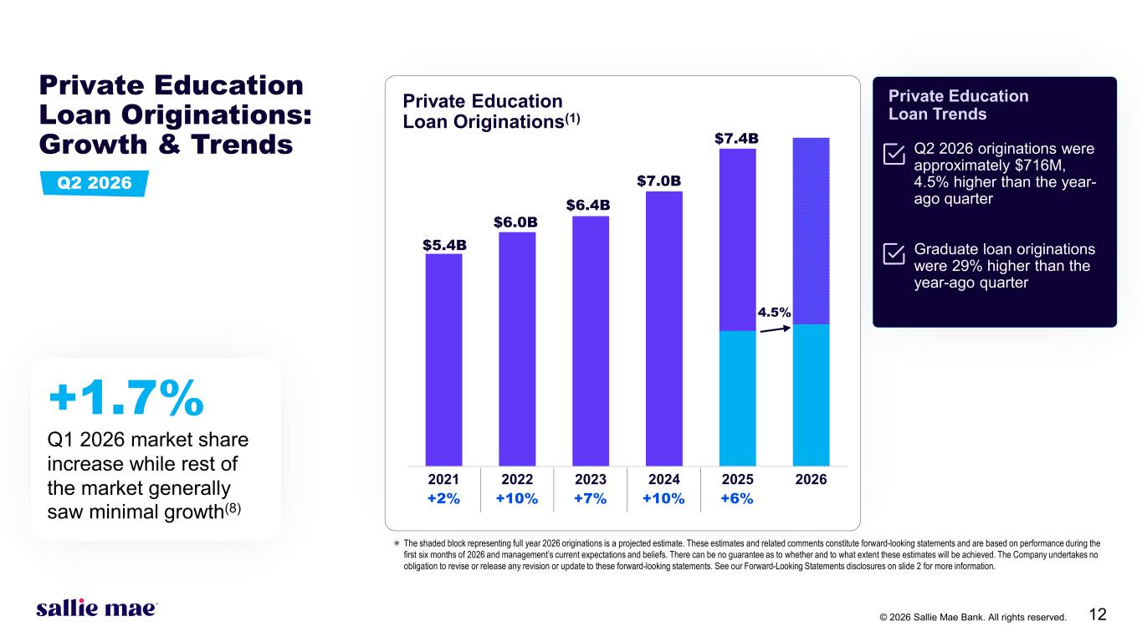
© 2026 Sallie Mae Bank. All rights reserved. 12 Private Education Loan Trends Q2 2026 originations were approximately $716M, 4.5% higher than the year- ago quarter Graduate loan originations were 29% higher than the year-ago quarter 2021 2022 2023 2024 2025 2026 Private Education Loan Originations: Growth & Trends $7.4B 4.5% Private Education Loan Originations(1) ⁕ The shaded block representing full year 2026 originations is a projected estimate. These estimates and related comments constitute forward-looking statements and are based on performance during the first six months of 2026 and management’s current expectations and beliefs. There can be no guarantee as to whether and to what extent these estimates will be achieved. The Company undertakes no obligation to revise or release any revision or update to these forward-looking statements. See our Forward-Looking Statements disclosures on slide 2 for more information. $7.0B $6.4B $6.0B $5.4B +2% +10% +7% +10% +6% +1.7% Q1 2026 market share increase while rest of the market generally saw minimal growth(8) Q2 2026

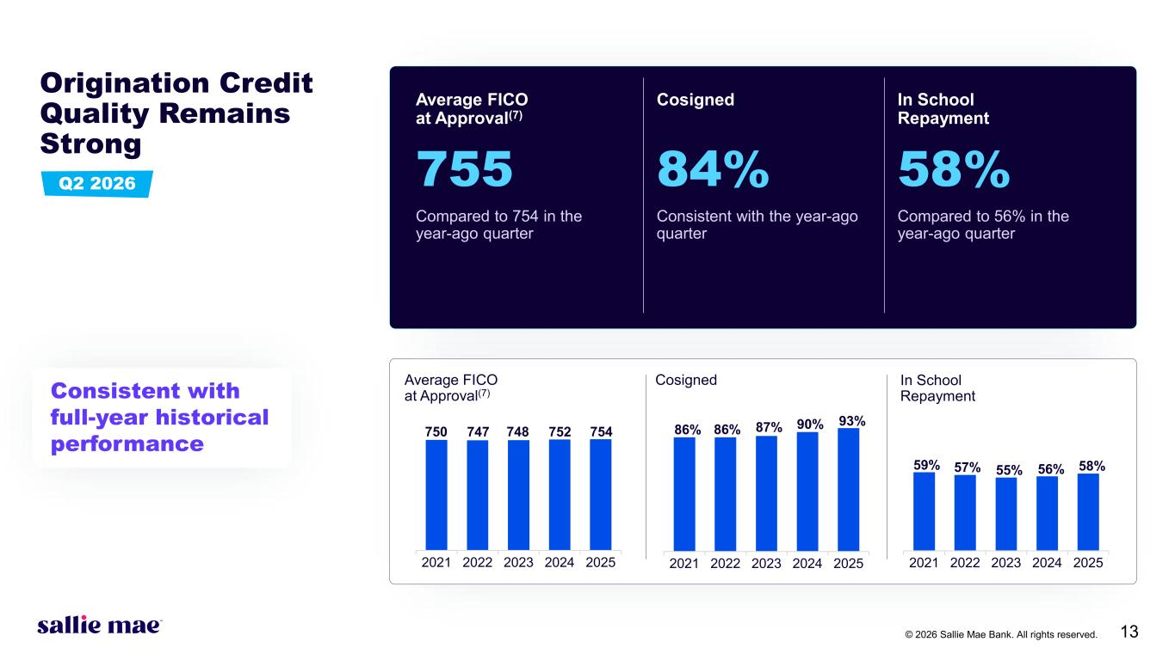
© 2026 Sallie Mae Bank. All rights reserved. 13 2021 2022 2023 2024 2025 Origination Credit Quality Remains Strong Average FICO at Approval(7) Cosigned In School Repayment 755 84% 58% Compared to 754 in the year-ago quarter Consistent with the year-ago quarter Compared to 56% in the year-ago quarter 2021 2022 2023 2024 2025 750 747 748 752 754 Average FICO at Approval(7) 86% 86% 87% 90% 93% Cosigned In School Repayment 2021 2022 2023 2024 2025 59% 57% 55% 56% 58% Consistent with full-year historical performance Q2 2026

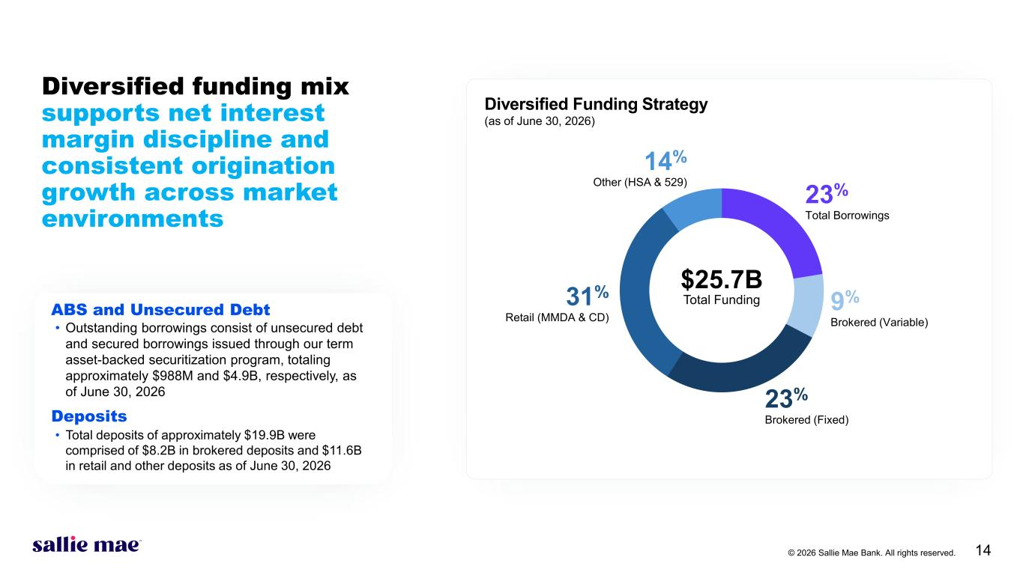
© 2026 Sallie Mae Bank. All rights reserved. 14 23% Total Borrowings 23% Brokered (Fixed) 14% Other (HSA & 529) 31% Retail (MMDA & CD) 9% Brokered (Variable) $25.7B Total Funding Diversified Funding Strategy (as of June 30, 2026) Diversified funding mix supports net interest margin discipline and consistent origination growth across market environments ABS and Unsecured Debt • Outstanding borrowings consist of unsecured debt and secured borrowings issued through our term asset-backed securitization program, totaling approximately $988M and $4.9B, respectively, as of June 30, 2026 Deposits • Total deposits of approximately $19.9B were comprised of $8.2B in brokered deposits and $11.6B in retail and other deposits as of June 30, 2026

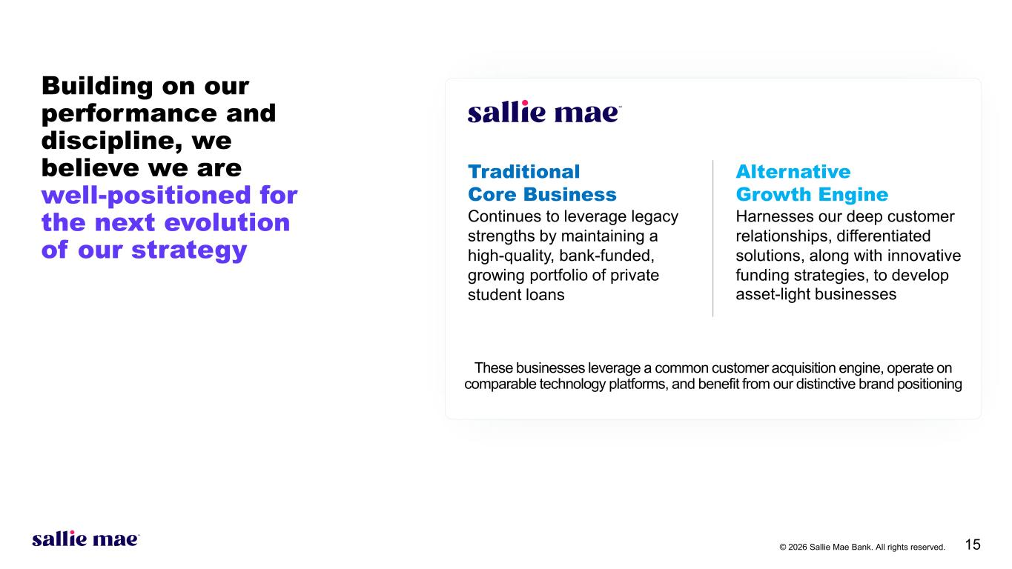
© 2026 Sallie Mae Bank. All rights reserved. 15 Building on our performance and discipline, we believe we are well-positioned for the next evolution of our strategy Traditional Core Business Alternative Growth Engine Continues to leverage legacy strengths by maintaining a high-quality, bank-funded, growing portfolio of private student loans Harnesses our deep customer relationships, differentiated solutions, along with innovative funding strategies, to develop asset-light businesses These businesses leverage a common customer acquisition engine, operate on comparable technology platforms, and benefit from our distinctive brand positioning

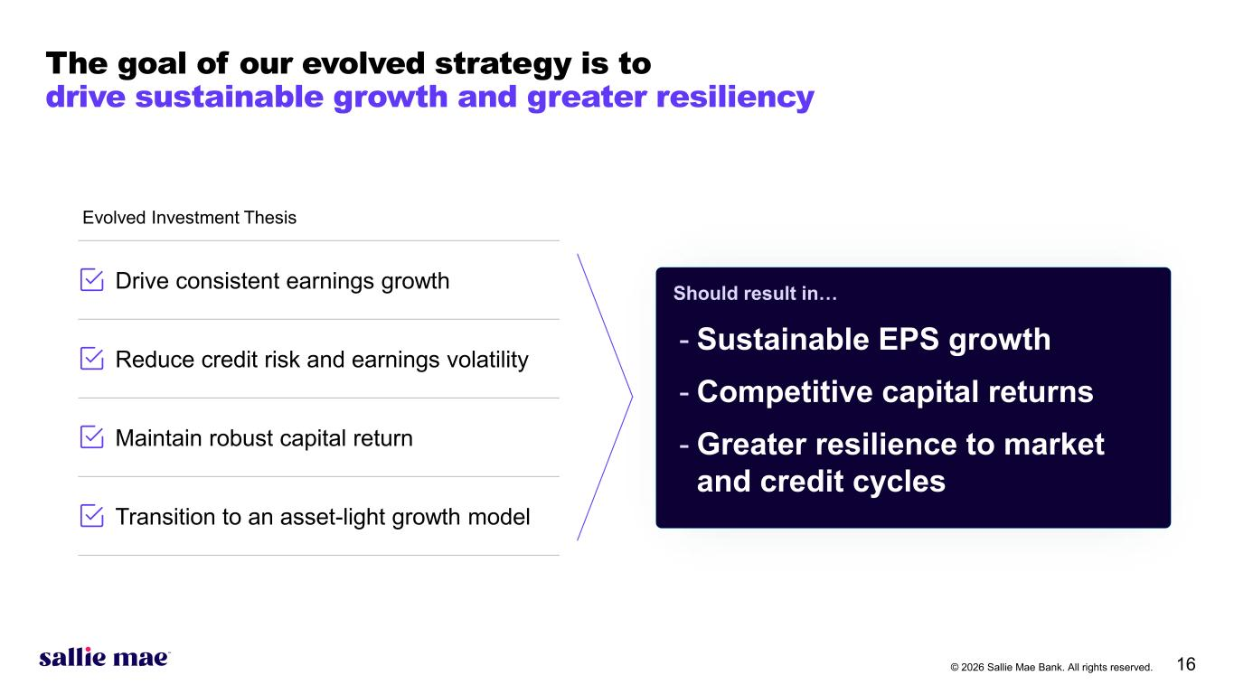
© 2026 Sallie Mae Bank. All rights reserved. 16 Drive consistent earnings growth Reduce credit risk and earnings volatility Maintain robust capital return Transition to an asset-light growth model Should result in… - Sustainable EPS growth - Competitive capital returns - Greater resilience to market and credit cycles Evolved Investment Thesis The goal of our evolved strategy is to drive sustainable growth and greater resiliency


© 2026 Sallie Mae Bank. All rights reserved. 17 Appendix

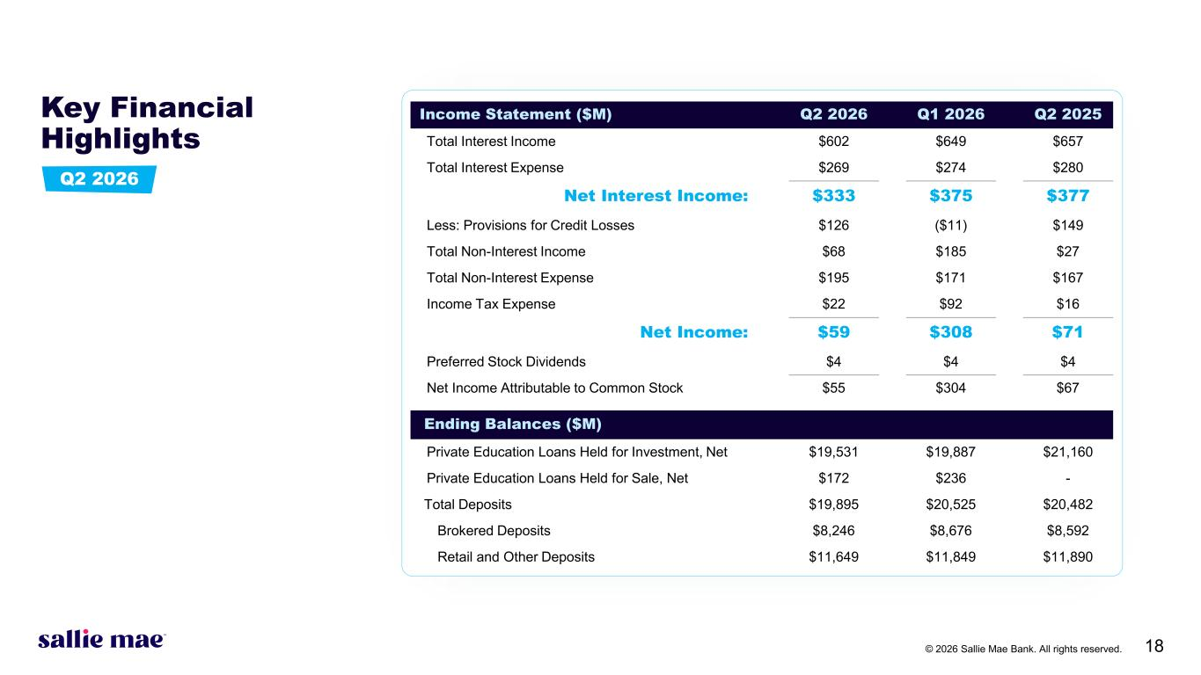
© 2026 Sallie Mae Bank. All rights reserved. 18 Key Financial Highlights Income Statement ($M) Q2 2026 Q1 2026 Q2 2025 Total Interest Income $602 $649 $657 Total Interest Expense $269 $274 $280 Net Interest Income: $333 $375 $377 Less: Provisions for Credit Losses $126 ($11) $149 Total Non-Interest Income $68 $185 $27 Total Non-Interest Expense $195 $171 $167 Income Tax Expense $22 $92 $16 Net Income: $59 $308 $71 Preferred Stock Dividends $4 $4 $4 Net Income Attributable to Common Stock $55 $304 $67 Ending Balances ($M) Private Education Loans Held for Investment, Net $19,531 $19,887 $21,160 Private Education Loans Held for Sale, Net $172 $236 - Total Deposits $19,895 $20,525 $20,482 Brokered Deposits $8,246 $8,676 $8,592 Retail and Other Deposits $11,649 $11,849 $11,890 Q2 2026

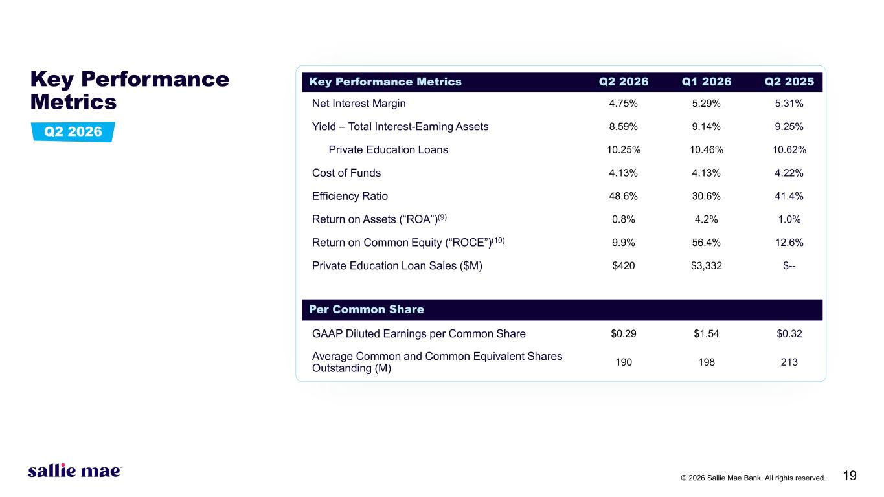
© 2026 Sallie Mae Bank. All rights reserved. 19 Key Performance Metrics Key Performance Metrics Q2 2026 Q1 2026 Q2 2025 Net Interest Margin 4.75% 5.29% 5.31% Yield – Total Interest-Earning Assets 8.59% 9.14% 9.25% Private Education Loans 10.25% 10.46% 10.62% Cost of Funds 4.13% 4.13% 4.22% Efficiency Ratio 48.6% 30.6% 41.4% Return on Assets (“ROA”)(9) 0.8% 4.2% 1.0% Return on Common Equity (“ROCE”)(10) 9.9% 56.4% 12.6% Private Education Loan Sales ($M) $420 $3,332 $-- Per Common Share GAAP Diluted Earnings per Common Share $0.29 $1.54 $0.32 Average Common and Common Equivalent Shares Outstanding (M) 190 198 213 Q2 2026

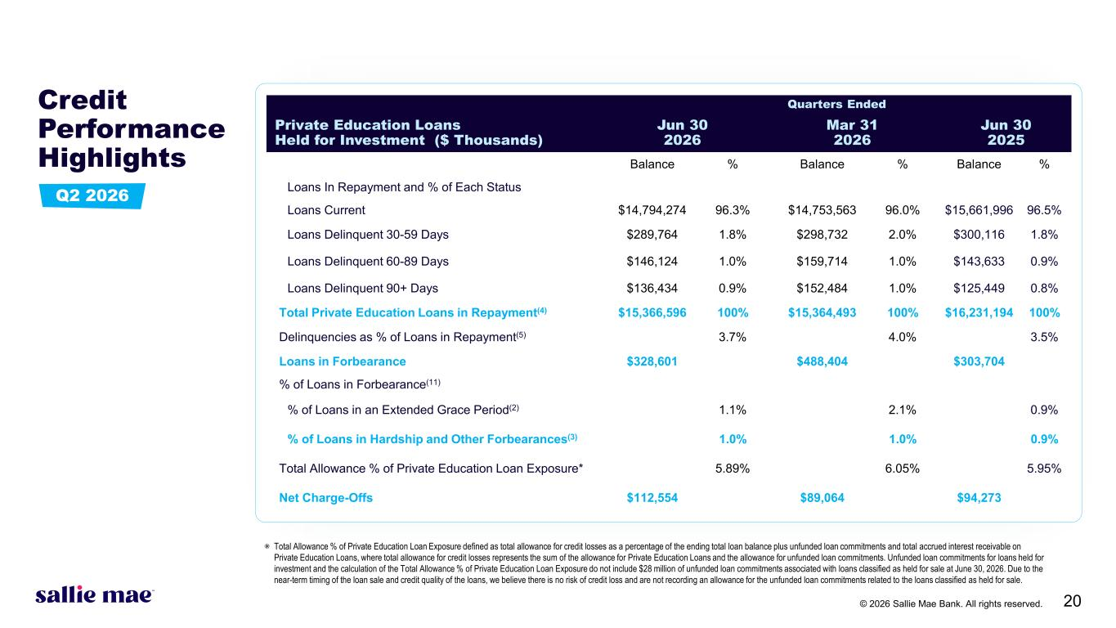
© 2026 Sallie Mae Bank. All rights reserved. 20 Credit Performance Highlights Quarters Ended Private Education Loans Held for Investment ($ Thousands) Jun 30 2026 Mar 31 2026 Jun 30 2025 Balance % Balance % Balance % Loans In Repayment and % of Each Status Loans Current $14,794,274 96.3% $14,753,563 96.0% $15,661,996 96.5% Loans Delinquent 30-59 Days $289,764 1.8% $298,732 2.0% $300,116 1.8% Loans Delinquent 60-89 Days $146,124 1.0% $159,714 1.0% $143,633 0.9% Loans Delinquent 90+ Days $136,434 0.9% $152,484 1.0% $125,449 0.8% Total Private Education Loans in Repayment(4) $15,366,596 100% $15,364,493 100% $16,231,194 100% Delinquencies as % of Loans in Repayment(5) 3.7% 4.0% 3.5% Loans in Forbearance $328,601 $488,404 $303,704 % of Loans in Forbearance(11) % of Loans in an Extended Grace Period(2) 1.1% 2.1% 0.9% % of Loans in Hardship and Other Forbearances(3) 1.0% 1.0% 0.9% Total Allowance % of Private Education Loan Exposure* 5.89% 6.05% 5.95% Net Charge-Offs $112,554 $89,064 $94,273 ⁕ Total Allowance % of Private Education Loan Exposure defined as total allowance for credit losses as a percentage of the ending total loan balance plus unfunded loan commitments and total accrued interest receivable on Private Education Loans, where total allowance for credit losses represents the sum of the allowance for Private Education Loans and the allowance for unfunded loan commitments. Unfunded loan commitments for loans held for investment and the calculation of the Total Allowance % of Private Education Loan Exposure do not include $28 million of unfunded loan commitments associated with loans classified as held for sale at June 30, 2026. Due to the near-term timing of the loan sale and credit quality of the loans, we believe there is no risk of credit loss and are not recording an allowance for the unfunded loan commitments related to the loans classified as held for sale. Q2 2026

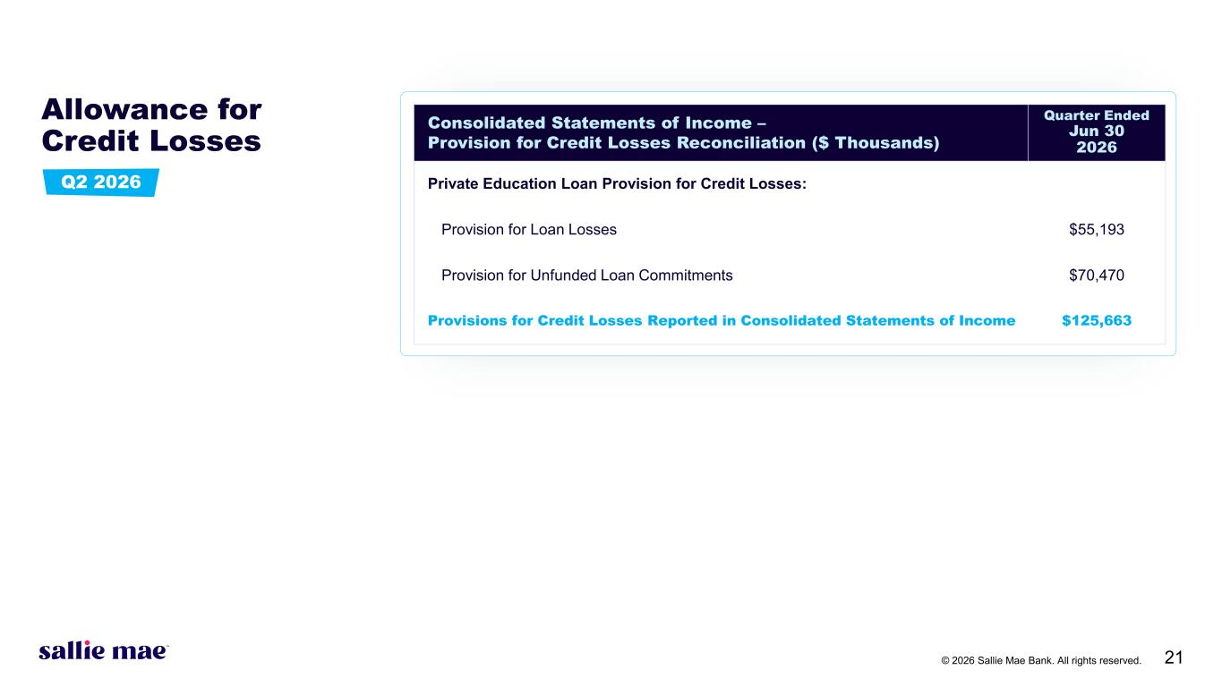
© 2026 Sallie Mae Bank. All rights reserved. 21 Allowance for Credit Losses Consolidated Statements of Income – Provision for Credit Losses Reconciliation ($ Thousands) Quarter Ended Jun 30 2026 Private Education Loan Provision for Credit Losses: Provision for Loan Losses $55,193 Provision for Unfunded Loan Commitments $70,470 Provisions for Credit Losses Reported in Consolidated Statements of Income $125,663 Q2 2026

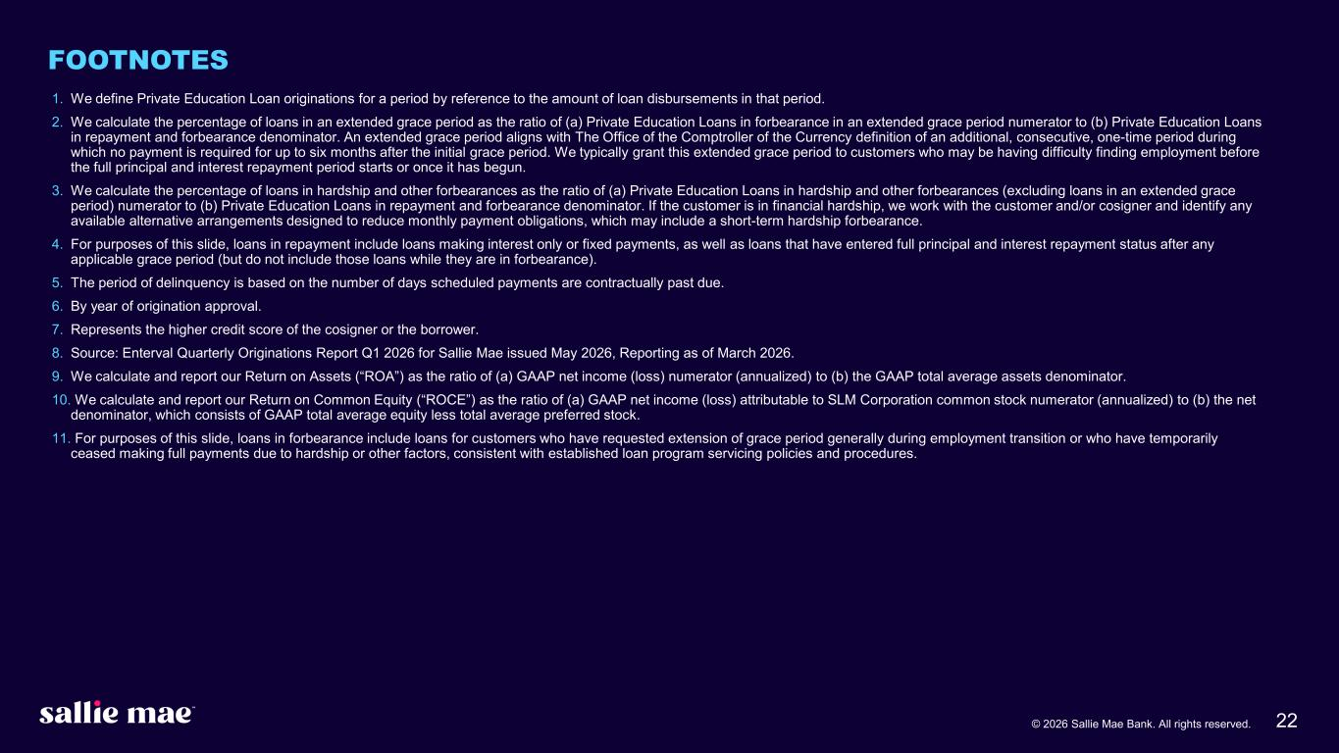
© 2026 Sallie Mae Bank. All rights reserved. 22 FOOTNOTES 1. We define Private Education Loan originations for a period by reference to the amount of loan disbursements in that period. 2. We calculate the percentage of loans in an extended grace period as the ratio of (a) Private Education Loans in forbearance in an extended grace period numerator to (b) Private Education Loans in repayment and forbearance denominator. An extended grace period aligns with The Office of the Comptroller of the Currency definition of an additional, consecutive, one-time period during which no payment is required for up to six months after the initial grace period. We typically grant this extended grace period to customers who may be having difficulty finding employment before the full principal and interest repayment period starts or once it has begun. 3. We calculate the percentage of loans in hardship and other forbearances as the ratio of (a) Private Education Loans in hardship and other forbearances (excluding loans in an extended grace period) numerator to (b) Private Education Loans in repayment and forbearance denominator. If the customer is in financial hardship, we work with the customer and/or cosigner and identify any available alternative arrangements designed to reduce monthly payment obligations, which may include a short-term hardship forbearance. 4. For purposes of this slide, loans in repayment include loans making interest only or fixed payments, as well as loans that have entered full principal and interest repayment status after any applicable grace period (but do not include those loans while they are in forbearance). 5. The period of delinquency is based on the number of days scheduled payments are contractually past due. 6. By year of origination approval. 7. Represents the higher credit score of the cosigner or the borrower. 8. Source: Enterval Quarterly Originations Report Q1 2026 for Sallie Mae issued May 2026, Reporting as of March 2026. 9. We calculate and report our Return on Assets (“ROA”) as the ratio of (a) GAAP net income (loss) numerator (annualized) to (b) the GAAP total average assets denominator. 10. We calculate and report our Return on Common Equity (“ROCE”) as the ratio of (a) GAAP net income (loss) attributable to SLM Corporation common stock numerator (annualized) to (b) the net denominator, which consists of GAAP total average equity less total average preferred stock. 11. For purposes of this slide, loans in forbearance include loans for customers who have requested extension of grace period generally during employment transition or who have temporarily ceased making full payments due to hardship or other factors, consistent with established loan program servicing policies and procedures.

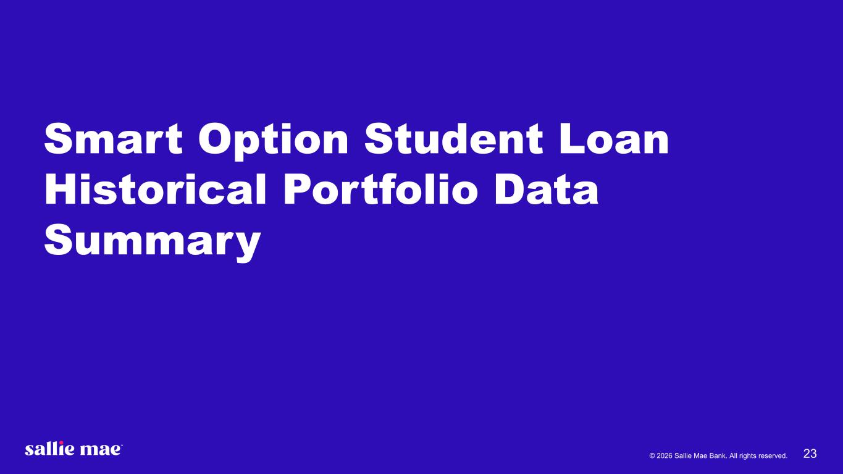
© 2026 Sallie Mae Bank. All rights reserved. 23 Smart Option Student Loan Historical Portfolio Data Summary

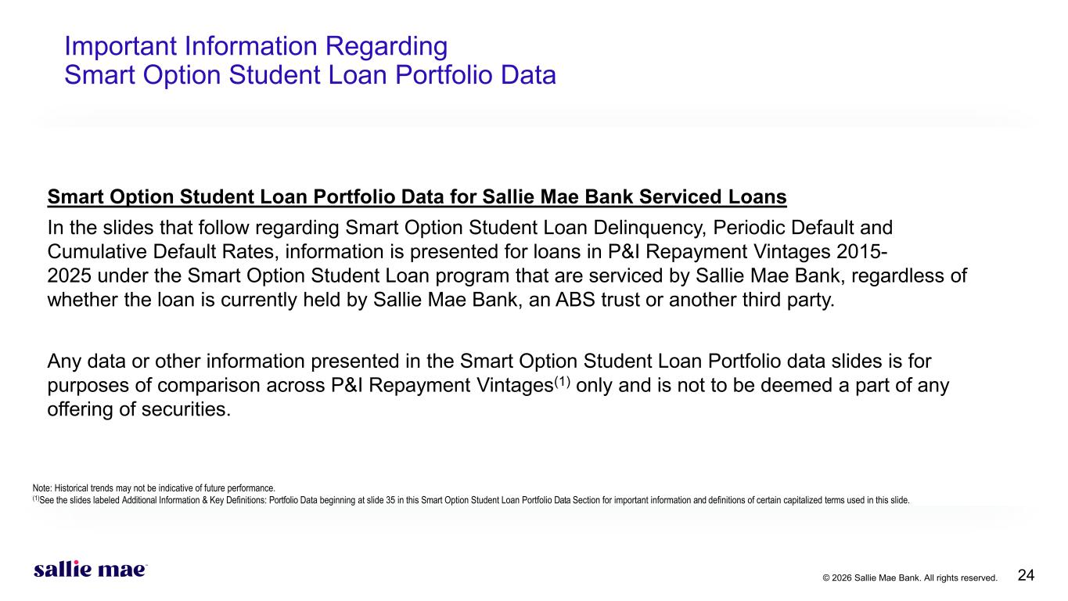
© 2026 Sallie Mae Bank. All rights reserved. 24 Important Information Regarding Smart Option Student Loan Portfolio Data Smart Option Student Loan Portfolio Data for Sallie Mae Bank Serviced Loans In the slides that follow regarding Smart Option Student Loan Delinquency, Periodic Default and Cumulative Default Rates, information is presented for loans in P&I Repayment Vintages 2015- 2025 under the Smart Option Student Loan program that are serviced by Sallie Mae Bank, regardless of whether the loan is currently held by Sallie Mae Bank, an ABS trust or another third party. Any data or other information presented in the Smart Option Student Loan Portfolio data slides is for purposes of comparison across P&I Repayment Vintages(1) only and is not to be deemed a part of any offering of securities. Note: Historical trends may not be indicative of future performance. (1)See the slides labeled Additional Information & Key Definitions: Portfolio Data beginning at slide 35 in this Smart Option Student Loan Portfolio Data Section for important information and definitions of certain capitalized terms used in this slide.

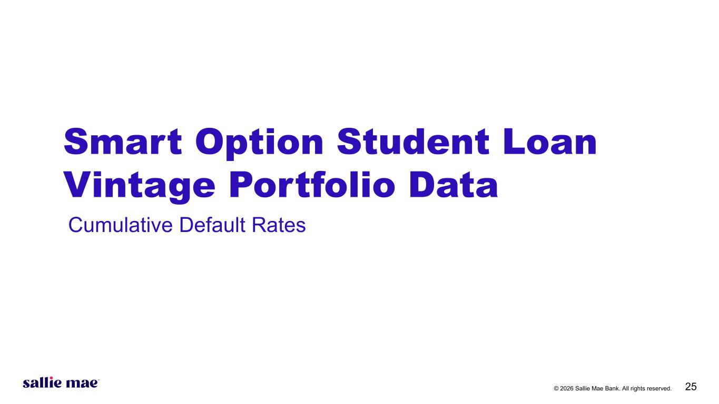
© 2026 Sallie Mae Bank. All rights reserved. 25 Smart Option Student Loan Vintage Portfolio Data Cumulative Default Rates

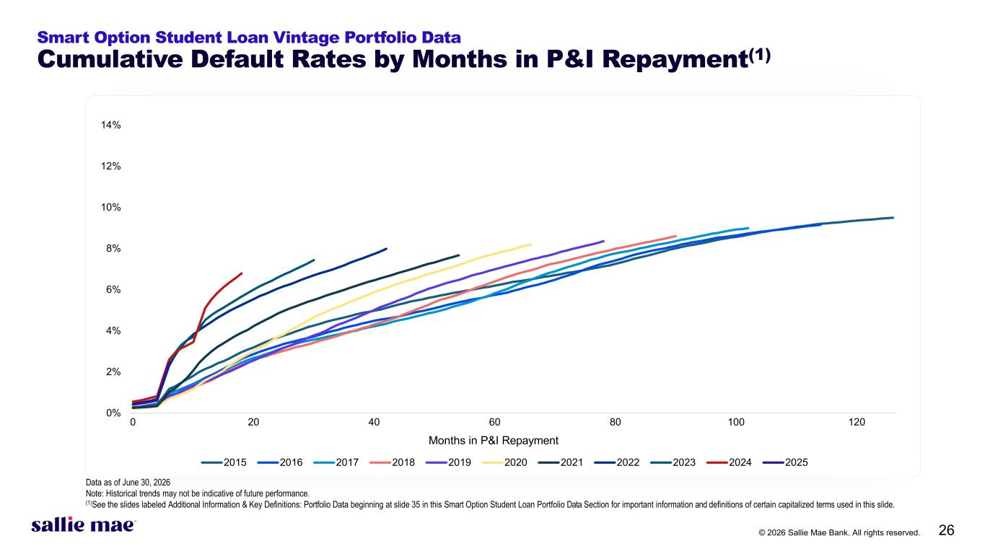
© 2026 Sallie Mae Bank. All rights reserved. 26 0% 2% 4% 6% 8% 10% 12% 14% 0 20 40 60 80 100 120 2015 2016 2017 2018 2019 2020 2021 2022 2023 2024 2025 Smart Option Student Loan Vintage Portfolio Data Cumulative Default Rates by Months in P&I Repayment(1) Months in P&I Repayment Data as of June 30, 2026 Note: Historical trends may not be indicative of future performance. (1)See the slides labeled Additional Information & Key Definitions: Portfolio Data beginning at slide 35 in this Smart Option Student Loan Portfolio Data Section for important information and definitions of certain capitalized terms used in this slide.

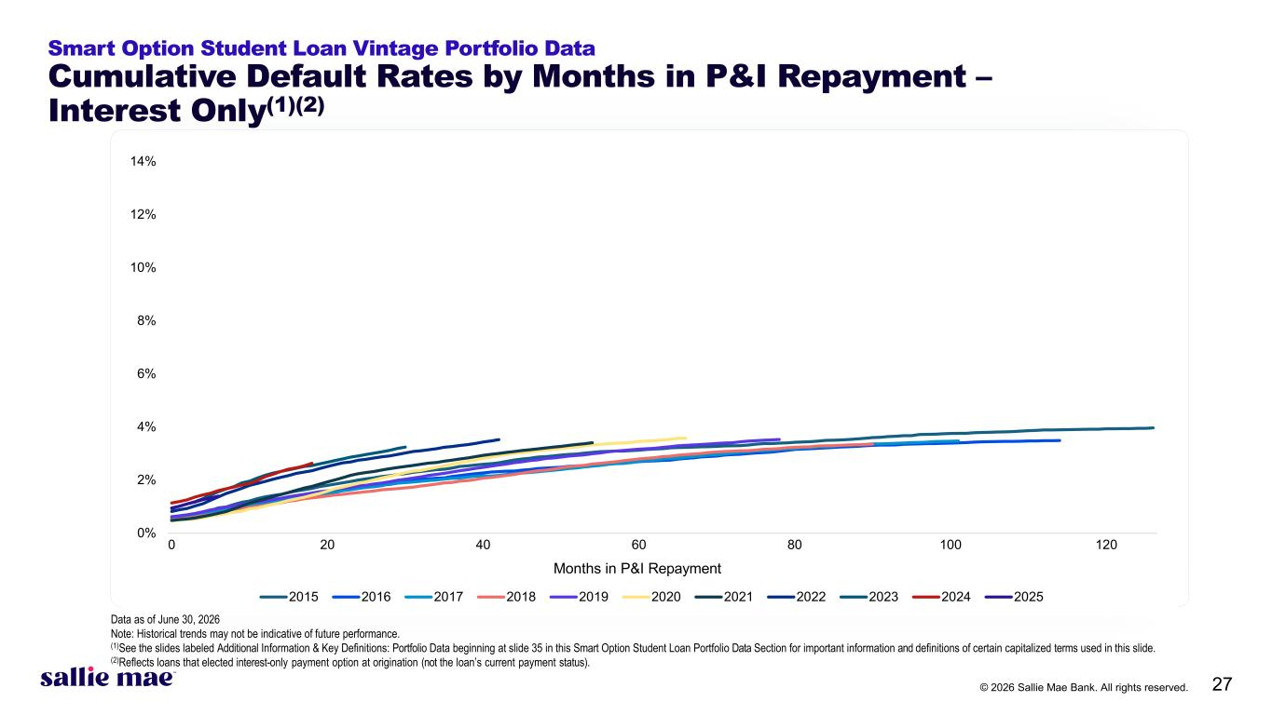
© 2026 Sallie Mae Bank. All rights reserved. 27 0% 2% 4% 6% 8% 10% 12% 14% 0 20 40 60 80 100 120 2015 2016 2017 2018 2019 2020 2021 2022 2023 2024 2025 Smart Option Student Loan Vintage Portfolio Data Cumulative Default Rates by Months in P&I Repayment – Interest Only(1)(2) Months in P&I Repayment Data as of June 30, 2026 Note: Historical trends may not be indicative of future performance. (1)See the slides labeled Additional Information & Key Definitions: Portfolio Data beginning at slide 35 in this Smart Option Student Loan Portfolio Data Section for important information and definitions of certain capitalized terms used in this slide. (2)Reflects loans that elected interest-only payment option at origination (not the loan’s current payment status).

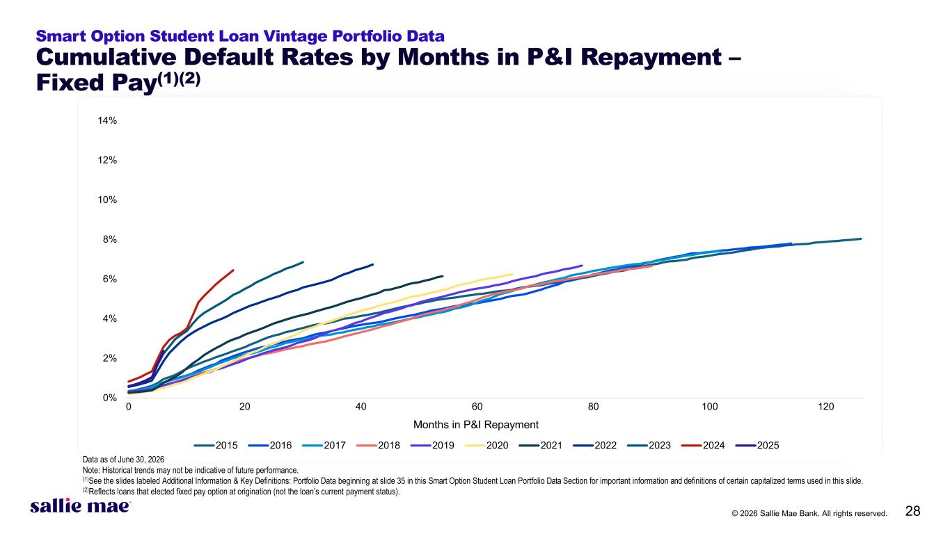
© 2026 Sallie Mae Bank. All rights reserved. 28 0% 2% 4% 6% 8% 10% 12% 14% 0 20 40 60 80 100 120 2015 2016 2017 2018 2019 2020 2021 2022 2023 2024 2025 Smart Option Student Loan Vintage Portfolio Data Cumulative Default Rates by Months in P&I Repayment – Fixed Pay(1)(2) Months in P&I Repayment Data as of June 30, 2026 Note: Historical trends may not be indicative of future performance. (1)See the slides labeled Additional Information & Key Definitions: Portfolio Data beginning at slide 35 in this Smart Option Student Loan Portfolio Data Section for important information and definitions of certain capitalized terms used in this slide. (2)Reflects loans that elected fixed pay option at origination (not the loan’s current payment status).

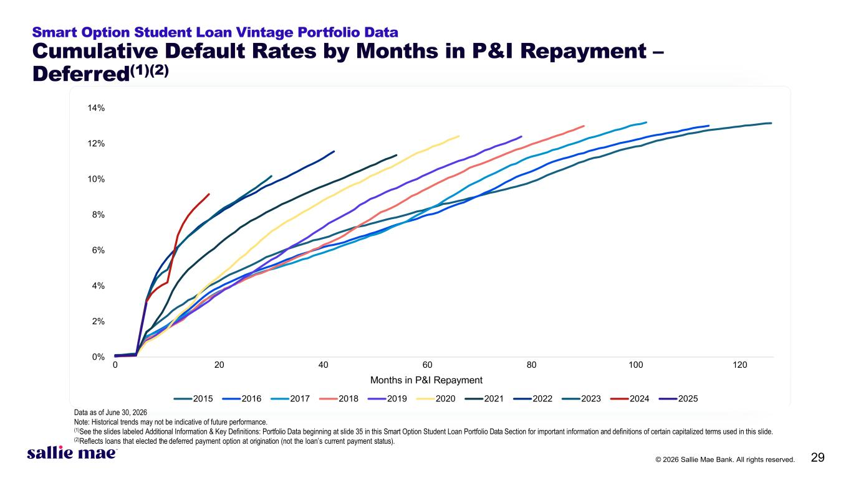
© 2026 Sallie Mae Bank. All rights reserved. 29 0% 2% 4% 6% 8% 10% 12% 14% 0 20 40 60 80 100 120 2015 2016 2017 2018 2019 2020 2021 2022 2023 2024 2025 Smart Option Student Loan Vintage Portfolio Data Cumulative Default Rates by Months in P&I Repayment – Deferred(1)(2) Months in P&I Repayment Data as of June 30, 2026 Note: Historical trends may not be indicative of future performance. (1)See the slides labeled Additional Information & Key Definitions: Portfolio Data beginning at slide 35 in this Smart Option Student Loan Portfolio Data Section for important information and definitions of certain capitalized terms used in this slide. (2)Reflects loans that elected the deferred payment option at origination (not the loan’s current payment status).

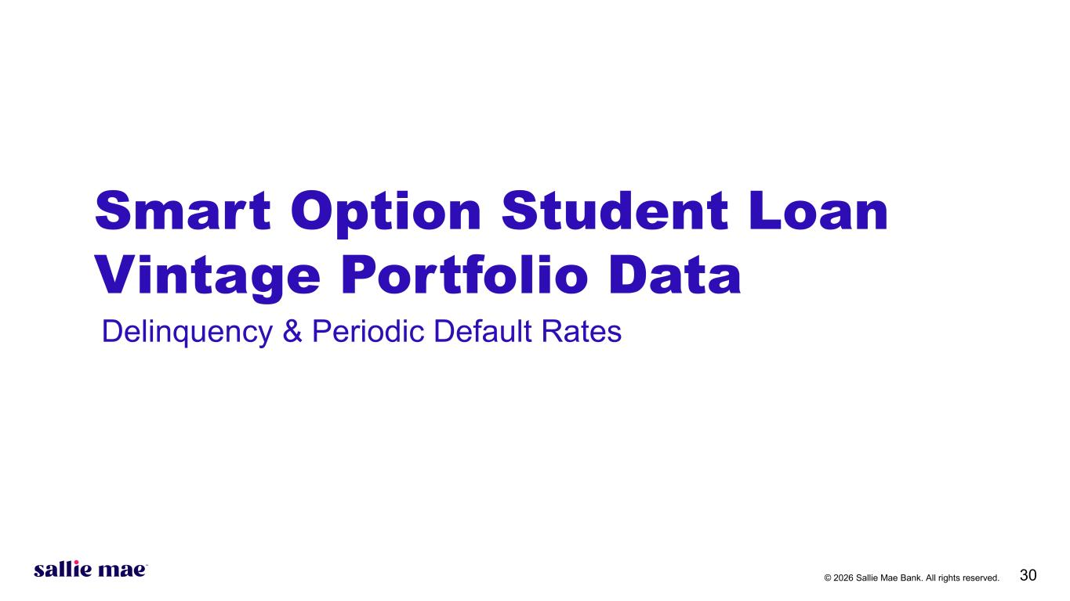
© 2026 Sallie Mae Bank. All rights reserved. 30 Smart Option Student Loan Vintage Portfolio Data Delinquency & Periodic Default Rates

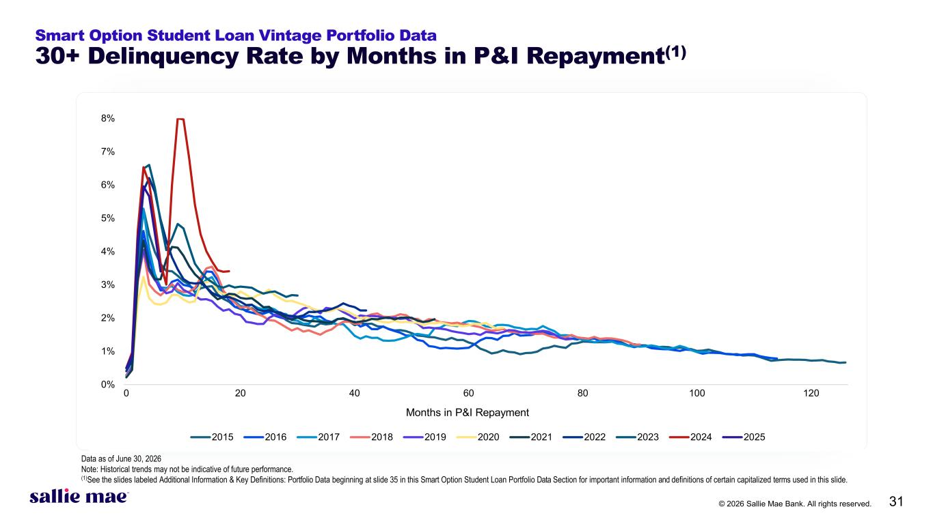
© 2026 Sallie Mae Bank. All rights reserved. 31 0% 1% 2% 3% 4% 5% 6% 7% 8% 0 20 40 60 80 100 120 2015 2016 2017 2018 2019 2020 2021 2022 2023 2024 2025 Smart Option Student Loan Vintage Portfolio Data 30+ Delinquency Rate by Months in P&I Repayment(1) Months in P&I Repayment Data as of June 30, 2026 Note: Historical trends may not be indicative of future performance. (1)See the slides labeled Additional Information & Key Definitions: Portfolio Data beginning at slide 35 in this Smart Option Student Loan Portfolio Data Section for important information and definitions of certain capitalized terms used in this slide.

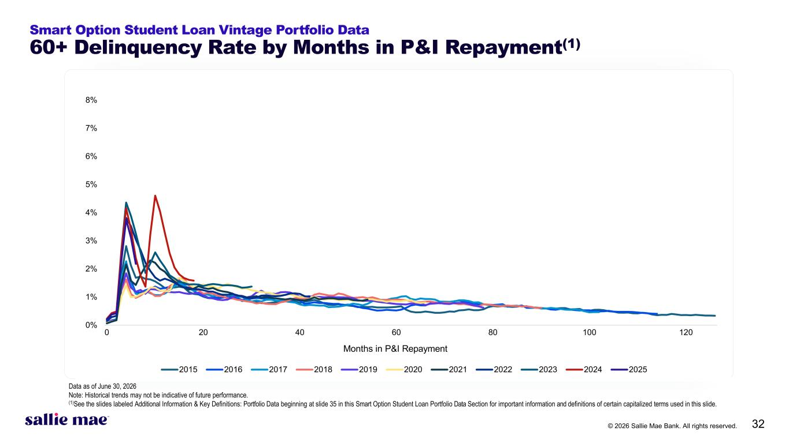
© 2026 Sallie Mae Bank. All rights reserved. 32 0% 1% 2% 3% 4% 5% 6% 7% 8% 0 20 40 60 80 100 120 2015 2016 2017 2018 2019 2020 2021 2022 2023 2024 2025 Smart Option Student Loan Vintage Portfolio Data 60+ Delinquency Rate by Months in P&I Repayment(1) Months in P&I Repayment Data as of June 30, 2026 Note: Historical trends may not be indicative of future performance. (1)See the slides labeled Additional Information & Key Definitions: Portfolio Data beginning at slide 35 in this Smart Option Student Loan Portfolio Data Section for important information and definitions of certain capitalized terms used in this slide.

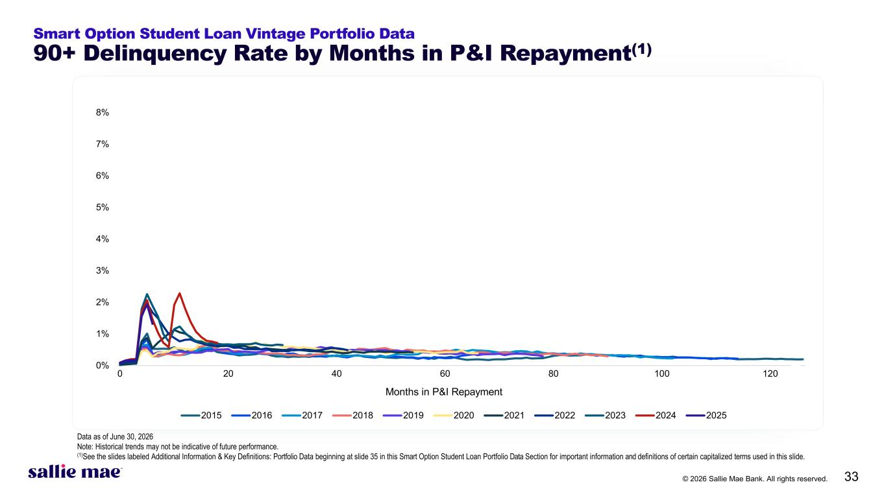
© 2026 Sallie Mae Bank. All rights reserved. 33 0% 1% 2% 3% 4% 5% 6% 7% 8% 0 20 40 60 80 100 120 2015 2016 2017 2018 2019 2020 2021 2022 2023 2024 2025 Smart Option Student Loan Vintage Portfolio Data 90+ Delinquency Rate by Months in P&I Repayment(1) Months in P&I Repayment Data as of June 30, 2026 Note: Historical trends may not be indicative of future performance. (1)See the slides labeled Additional Information & Key Definitions: Portfolio Data beginning at slide 35 in this Smart Option Student Loan Portfolio Data Section for important information and definitions of certain capitalized terms used in this slide.

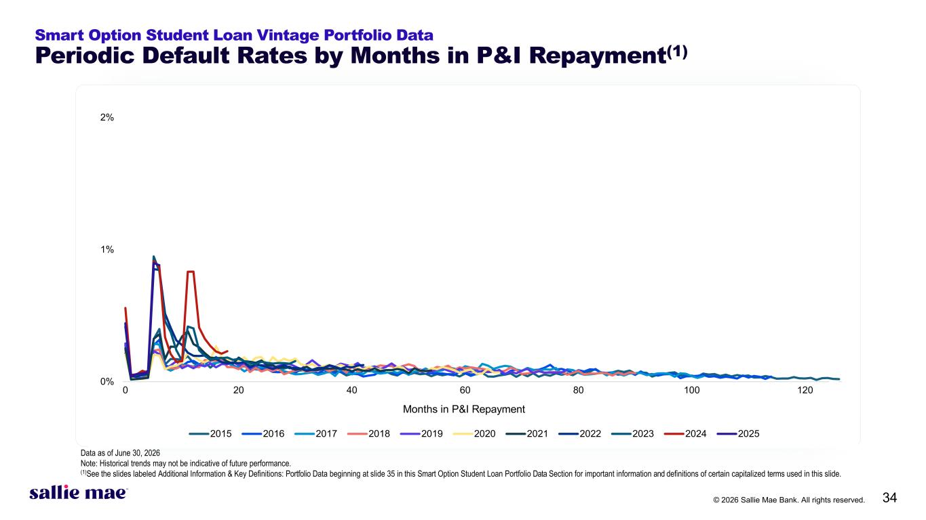
© 2026 Sallie Mae Bank. All rights reserved. 34 0% 1% 2% 0 20 40 60 80 100 120 2015 2016 2017 2018 2019 2020 2021 2022 2023 2024 2025 Smart Option Student Loan Vintage Portfolio Data Periodic Default Rates by Months in P&I Repayment(1) Months in P&I Repayment Data as of June 30, 2026 Note: Historical trends may not be indicative of future performance. (1)See the slides labeled Additional Information & Key Definitions: Portfolio Data beginning at slide 35 in this Smart Option Student Loan Portfolio Data Section for important information and definitions of certain capitalized terms used in this slide.

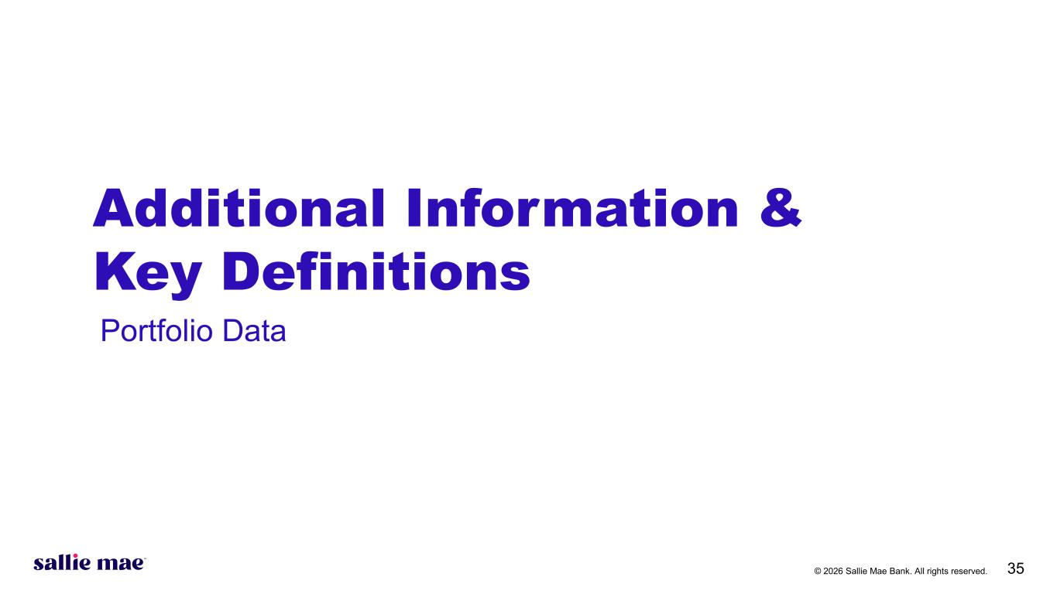
© 2026 Sallie Mae Bank. All rights reserved. 35 Additional Information & Key Definitions Portfolio Data

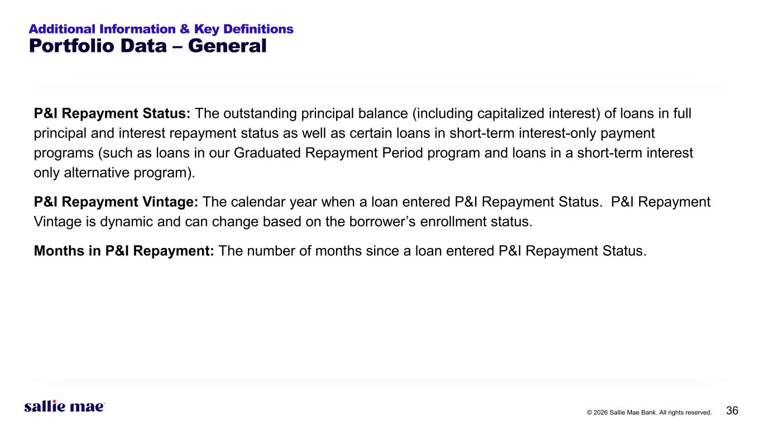
© 2026 Sallie Mae Bank. All rights reserved. 36 Additional Information & Key Definitions Portfolio Data – General P&I Repayment Status: The outstanding principal balance (including capitalized interest) of loans in full principal and interest repayment status as well as certain loans in short-term interest-only payment programs (such as loans in our Graduated Repayment Period program and loans in a short-term interest only alternative program). P&I Repayment Vintage: The calendar year when a loan entered P&I Repayment Status. P&I Repayment Vintage is dynamic and can change based on the borrower’s enrollment status. Months in P&I Repayment: The number of months since a loan entered P&I Repayment Status.

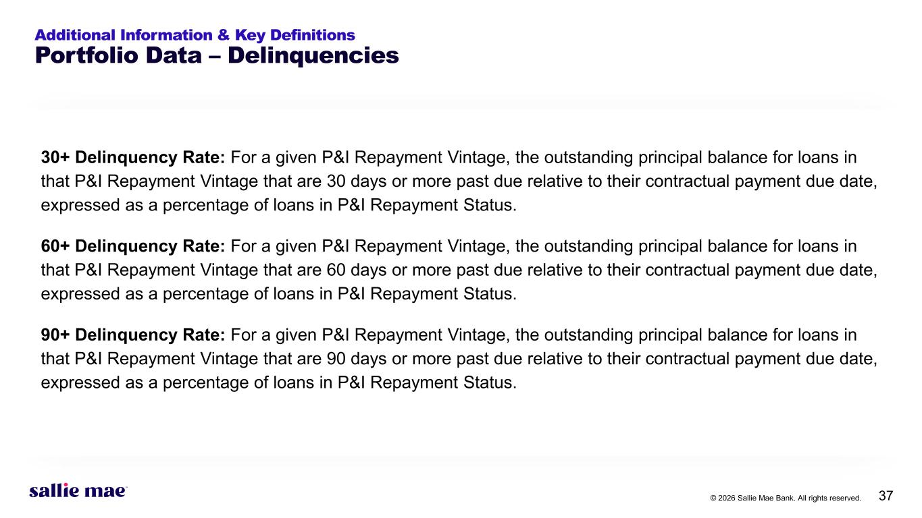
© 2026 Sallie Mae Bank. All rights reserved. 37 Additional Information & Key Definitions Portfolio Data – Delinquencies 30+ Delinquency Rate: For a given P&I Repayment Vintage, the outstanding principal balance for loans in that P&I Repayment Vintage that are 30 days or more past due relative to their contractual payment due date, expressed as a percentage of loans in P&I Repayment Status. 60+ Delinquency Rate: For a given P&I Repayment Vintage, the outstanding principal balance for loans in that P&I Repayment Vintage that are 60 days or more past due relative to their contractual payment due date, expressed as a percentage of loans in P&I Repayment Status. 90+ Delinquency Rate: For a given P&I Repayment Vintage, the outstanding principal balance for loans in that P&I Repayment Vintage that are 90 days or more past due relative to their contractual payment due date, expressed as a percentage of loans in P&I Repayment Status.

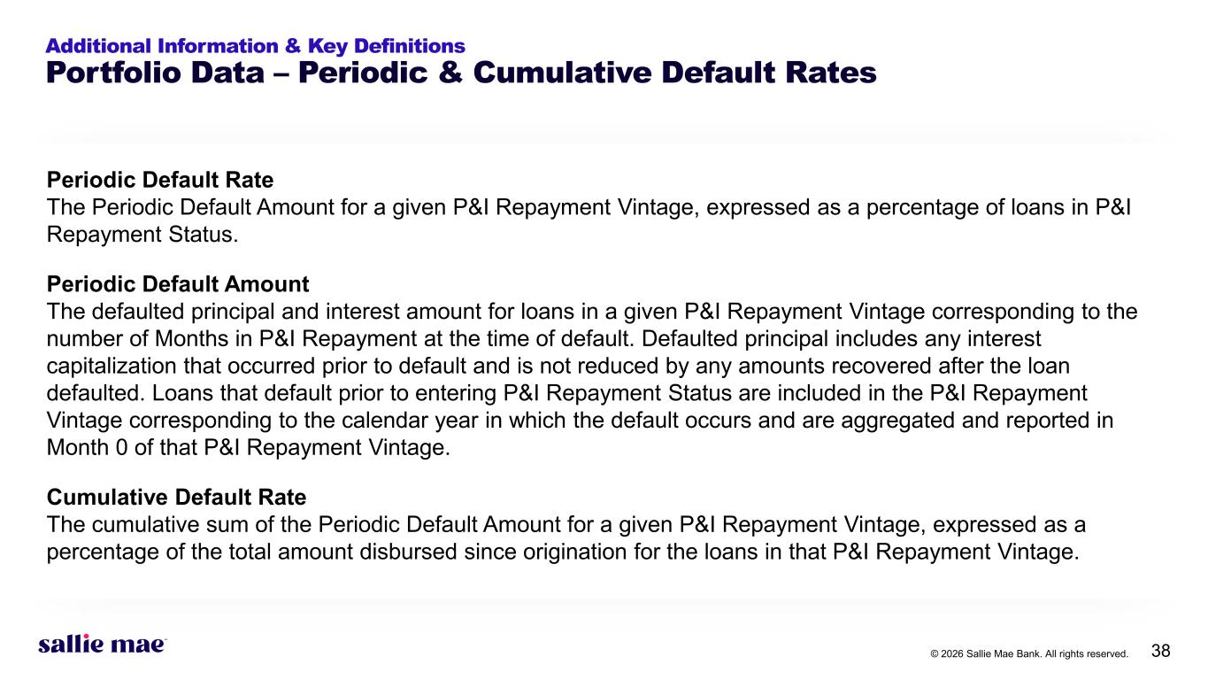
© 2026 Sallie Mae Bank. All rights reserved. 38 Additional Information & Key Definitions Portfolio Data – Periodic & Cumulative Default Rates Periodic Default Rate The Periodic Default Amount for a given P&I Repayment Vintage, expressed as a percentage of loans in P&I Repayment Status. Periodic Default Amount The defaulted principal and interest amount for loans in a given P&I Repayment Vintage corresponding to the number of Months in P&I Repayment at the time of default. Defaulted principal includes any interest capitalization that occurred prior to default and is not reduced by any amounts recovered after the loan defaulted. Loans that default prior to entering P&I Repayment Status are included in the P&I Repayment Vintage corresponding to the calendar year in which the default occurs and are aggregated and reported in Month 0 of that P&I Repayment Vintage. Cumulative Default Rate The cumulative sum of the Periodic Default Amount for a given P&I Repayment Vintage, expressed as a percentage of the total amount disbursed since origination for the loans in that P&I Repayment Vintage.

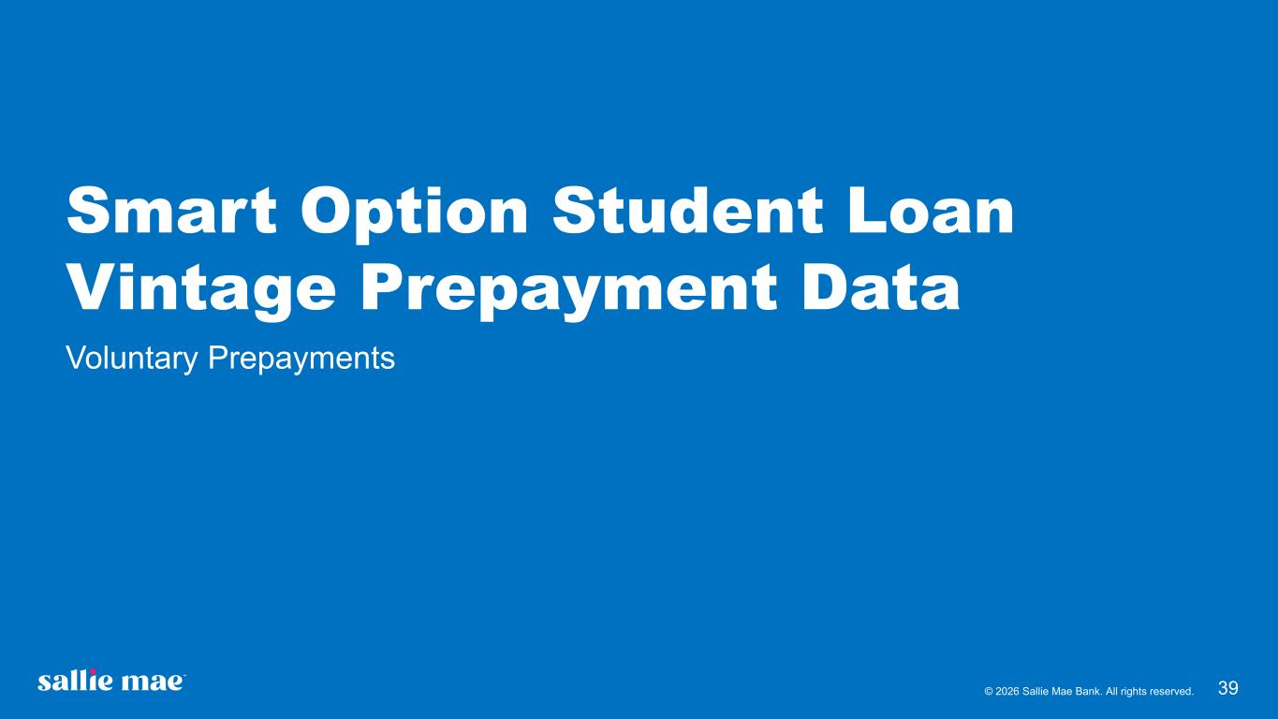
© 2026 Sallie Mae Bank. All rights reserved. 39 Smart Option Student Loan Vintage Prepayment Data Voluntary Prepayments

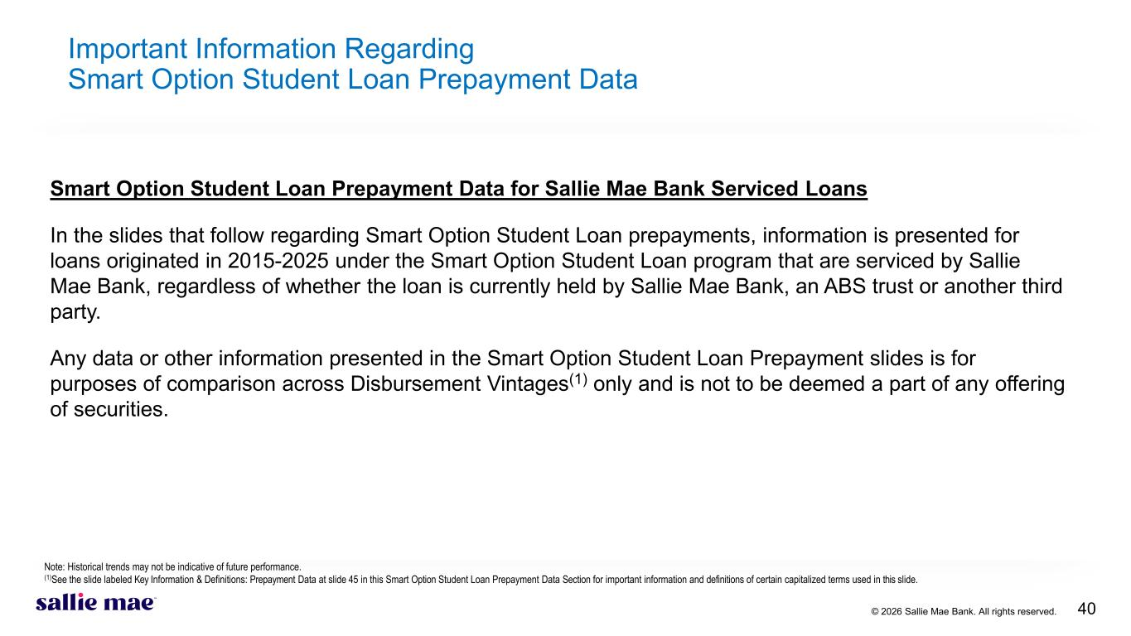
© 2026 Sallie Mae Bank. All rights reserved. 40 Important Information Regarding Smart Option Student Loan Prepayment Data Smart Option Student Loan Prepayment Data for Sallie Mae Bank Serviced Loans In the slides that follow regarding Smart Option Student Loan prepayments, information is presented for loans originated in 2015-2025 under the Smart Option Student Loan program that are serviced by Sallie Mae Bank, regardless of whether the loan is currently held by Sallie Mae Bank, an ABS trust or another third party. Any data or other information presented in the Smart Option Student Loan Prepayment slides is for purposes of comparison across Disbursement Vintages(1) only and is not to be deemed a part of any offering of securities. Note: Historical trends may not be indicative of future performance. (1)See the slide labeled Key Information & Definitions: Prepayment Data at slide 45 in this Smart Option Student Loan Prepayment Data Section for important information and definitions of certain capitalized terms used in this slide.

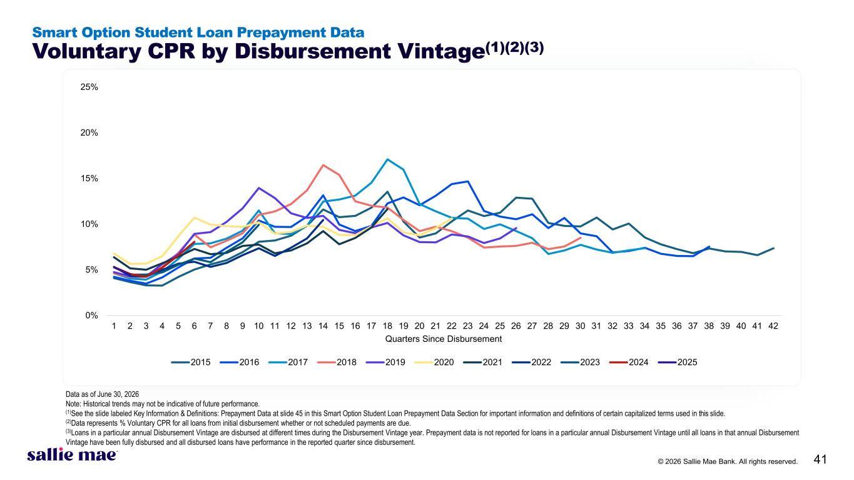
© 2026 Sallie Mae Bank. All rights reserved. 41 0% 5% 10% 15% 20% 25% 1 2 3 4 5 6 7 8 9 10 11 12 13 14 15 16 17 18 19 20 21 22 23 24 25 26 27 28 29 30 31 32 33 34 35 36 37 38 39 40 41 42 Quarters Since Disbursement 2015 2016 2017 2018 2019 2020 2021 2022 2023 2024 2025 Smart Option Student Loan Prepayment Data Voluntary CPR by Disbursement Vintage(1)(2)(3) Data as of June 30, 2026 Note: Historical trends may not be indicative of future performance. (1)See the slide labeled Key Information & Definitions: Prepayment Data at slide 45 in this Smart Option Student Loan Prepayment Data Section for important information and definitions of certain capitalized terms used in this slide. (2)Data represents % Voluntary CPR for all loans from initial disbursement whether or not scheduled payments are due. (3)Loans in a particular annual Disbursement Vintage are disbursed at different times during the Disbursement Vintage year. Prepayment data is not reported for loans in a particular annual Disbursement Vintage until all loans in that annual Disbursement Vintage have been fully disbursed and all disbursed loans have performance in the reported quarter since disbursement.

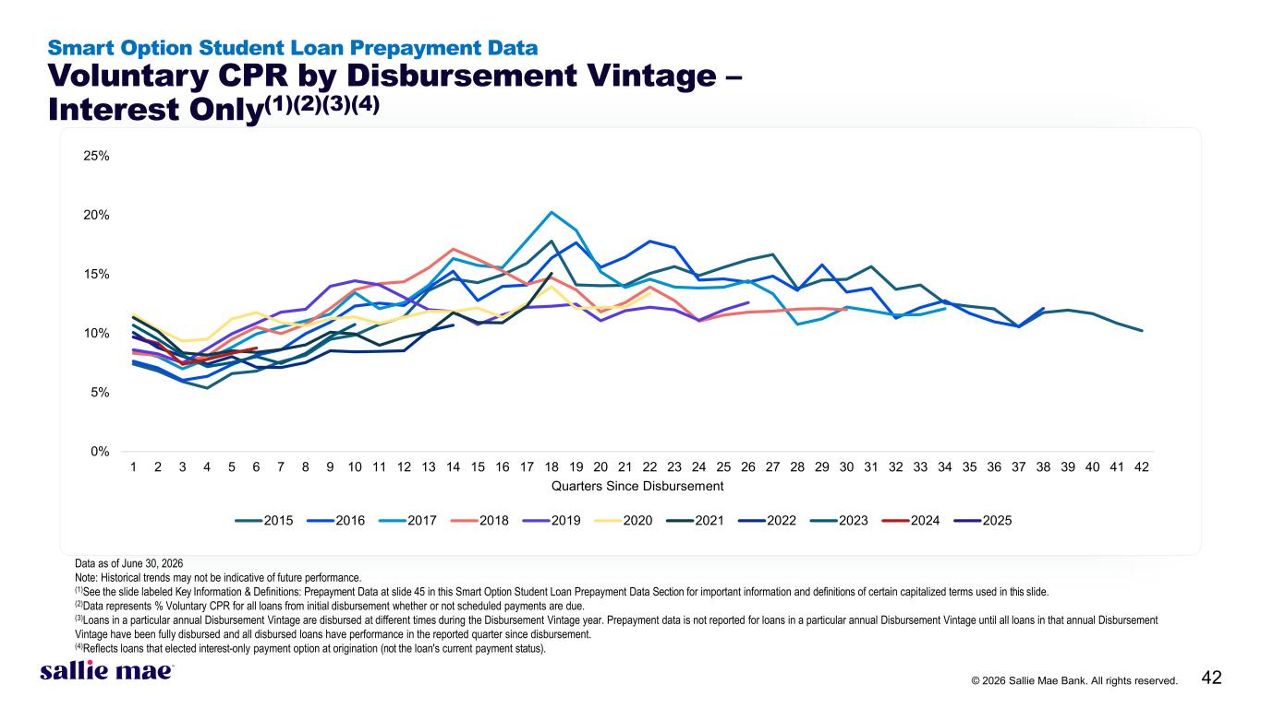
© 2026 Sallie Mae Bank. All rights reserved. 42 Smart Option Student Loan Prepayment Data Voluntary CPR by Disbursement Vintage – Interest Only(1)(2)(3)(4) Data as of June 30, 2026 Note: Historical trends may not be indicative of future performance. (1)See the slide labeled Key Information & Definitions: Prepayment Data at slide 45 in this Smart Option Student Loan Prepayment Data Section for important information and definitions of certain capitalized terms used in this slide. (2)Data represents % Voluntary CPR for all loans from initial disbursement whether or not scheduled payments are due. (3)Loans in a particular annual Disbursement Vintage are disbursed at different times during the Disbursement Vintage year. Prepayment data is not reported for loans in a particular annual Disbursement Vintage until all loans in that annual Disbursement Vintage have been fully disbursed and all disbursed loans have performance in the reported quarter since disbursement. (4)Reflects loans that elected interest-only payment option at origination (not the loan's current payment status). 0% 5% 10% 15% 20% 25% 1 2 3 4 5 6 7 8 9 10 11 12 13 14 15 16 17 18 19 20 21 22 23 24 25 26 27 28 29 30 31 32 33 34 35 36 37 38 39 40 41 42 Quarters Since Disbursement 2015 2016 2017 2018 2019 2020 2021 2022 2023 2024 2025

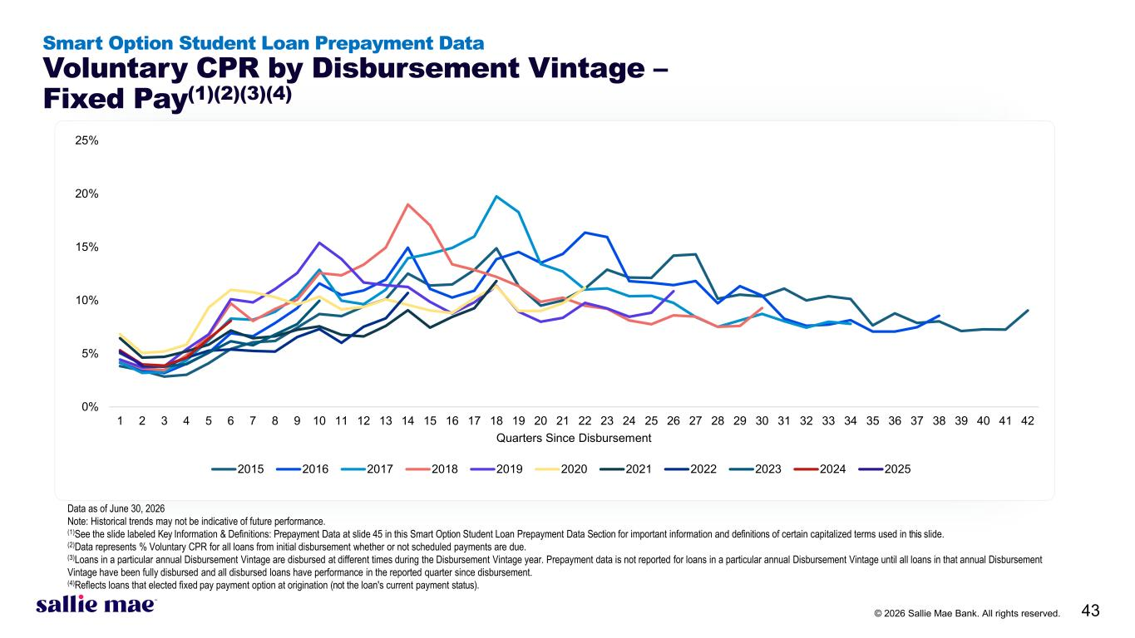
© 2026 Sallie Mae Bank. All rights reserved. 43 Smart Option Student Loan Prepayment Data Voluntary CPR by Disbursement Vintage – Fixed Pay(1)(2)(3)(4) Data as of June 30, 2026 Note: Historical trends may not be indicative of future performance. (1)See the slide labeled Key Information & Definitions: Prepayment Data at slide 45 in this Smart Option Student Loan Prepayment Data Section for important information and definitions of certain capitalized terms used in this slide. (2)Data represents % Voluntary CPR for all loans from initial disbursement whether or not scheduled payments are due. (3)Loans in a particular annual Disbursement Vintage are disbursed at different times during the Disbursement Vintage year. Prepayment data is not reported for loans in a particular annual Disbursement Vintage until all loans in that annual Disbursement Vintage have been fully disbursed and all disbursed loans have performance in the reported quarter since disbursement. (4)Reflects loans that elected fixed pay payment option at origination (not the loan's current payment status). 0% 5% 10% 15% 20% 25% 1 2 3 4 5 6 7 8 9 10 11 12 13 14 15 16 17 18 19 20 21 22 23 24 25 26 27 28 29 30 31 32 33 34 35 36 37 38 39 40 41 42 Quarters Since Disbursement 2015 2016 2017 2018 2019 2020 2021 2022 2023 2024 2025

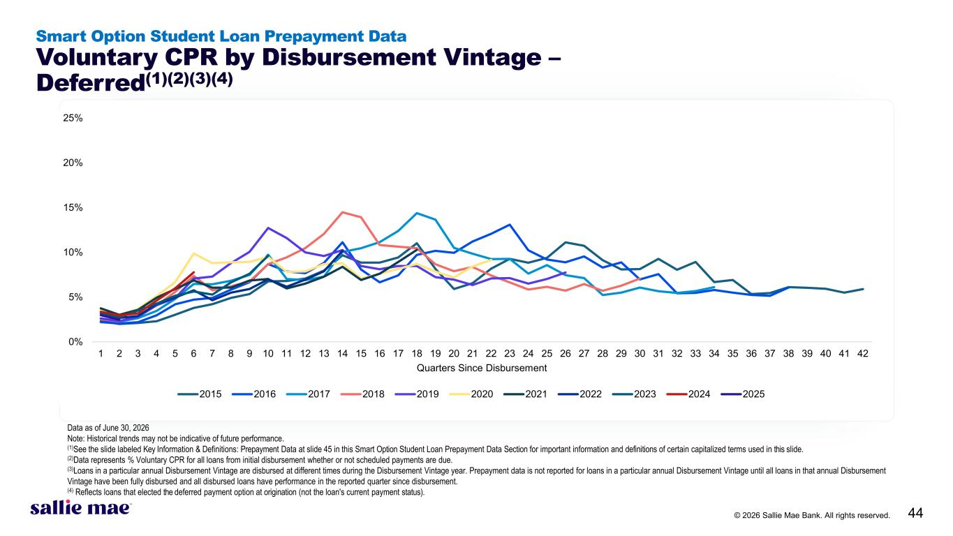
© 2026 Sallie Mae Bank. All rights reserved. 44 Smart Option Student Loan Prepayment Data Voluntary CPR by Disbursement Vintage – Deferred(1)(2)(3)(4) Data as of June 30, 2026 Note: Historical trends may not be indicative of future performance. (1)See the slide labeled Key Information & Definitions: Prepayment Data at slide 45 in this Smart Option Student Loan Prepayment Data Section for important information and definitions of certain capitalized terms used in this slide. (2)Data represents % Voluntary CPR for all loans from initial disbursement whether or not scheduled payments are due. (3)Loans in a particular annual Disbursement Vintage are disbursed at different times during the Disbursement Vintage year. Prepayment data is not reported for loans in a particular annual Disbursement Vintage until all loans in that annual Disbursement Vintage have been fully disbursed and all disbursed loans have performance in the reported quarter since disbursement. (4) Reflects loans that elected the deferred payment option at origination (not the loan's current payment status). 0% 5% 10% 15% 20% 25% 1 2 3 4 5 6 7 8 9 10 11 12 13 14 15 16 17 18 19 20 21 22 23 24 25 26 27 28 29 30 31 32 33 34 35 36 37 38 39 40 41 42 Quarters Since Disbursement 2015 2016 2017 2018 2019 2020 2021 2022 2023 2024 2025

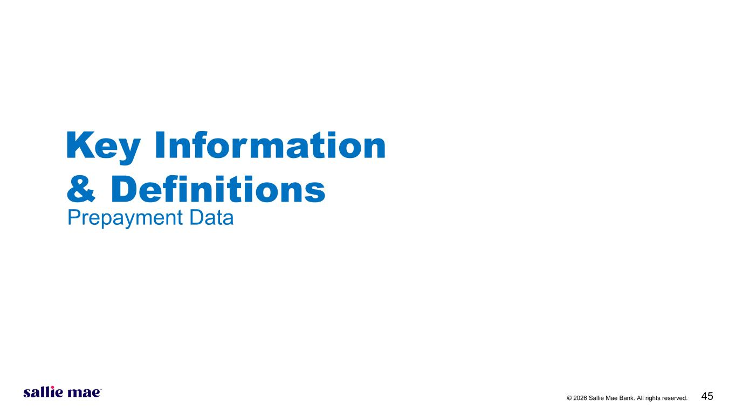
© 2026 Sallie Mae Bank. All rights reserved. 45 Key Information & Definitions Prepayment Data

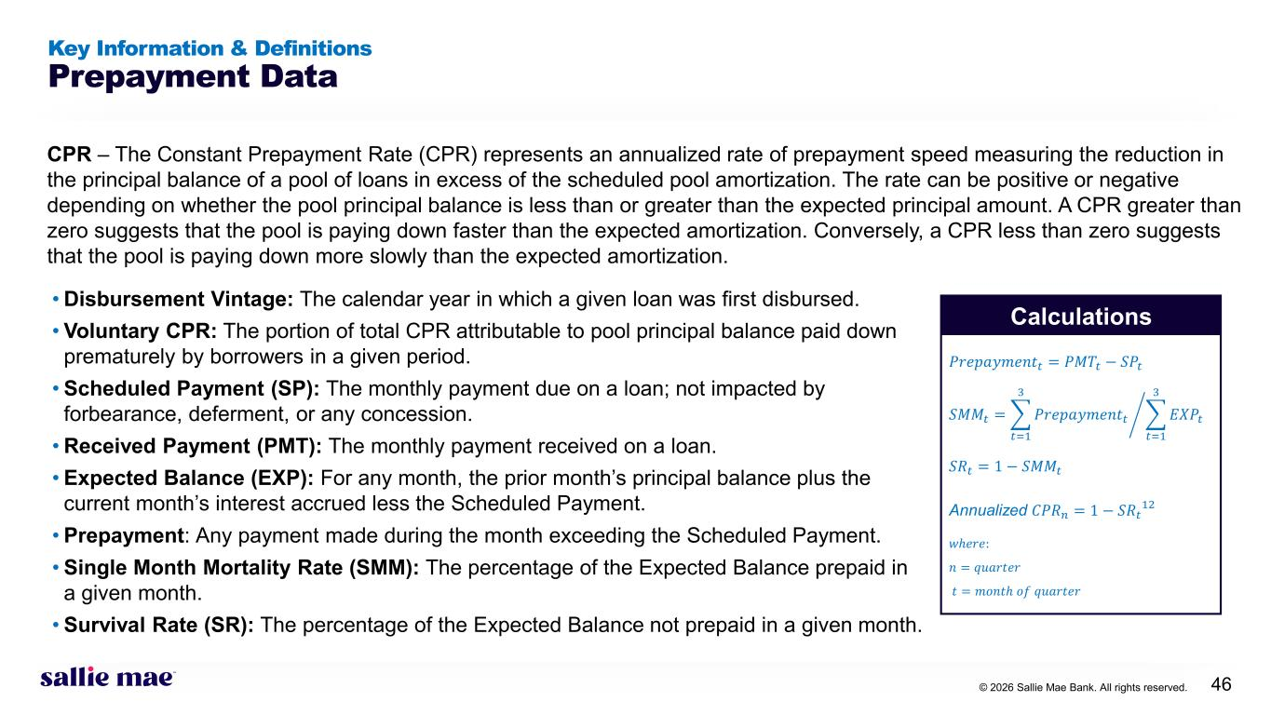
© 2026 Sallie Mae Bank. All rights reserved. 46 Key Information & Definitions Prepayment Data CPR – The Constant Prepayment Rate (CPR) represents an annualized rate of prepayment speed measuring the reduction in the principal balance of a pool of loans in excess of the scheduled pool amortization. The rate can be positive or negative depending on whether the pool principal balance is less than or greater than the expected principal amount. A CPR greater than zero suggests that the pool is paying down faster than the expected amortization. Conversely, a CPR less than zero suggests that the pool is paying down more slowly than the expected amortization. • Disbursement Vintage: The calendar year in which a given loan was first disbursed. • Voluntary CPR: The portion of total CPR attributable to pool principal balance paid down prematurely by borrowers in a given period. • Scheduled Payment (SP): The monthly payment due on a loan; not impacted by forbearance, deferment, or any concession. • Received Payment (PMT): The monthly payment received on a loan. • Expected Balance (EXP): For any month, the prior month’s principal balance plus the current month’s interest accrued less the Scheduled Payment. • Prepayment: Any payment made during the month exceeding the Scheduled Payment. • Single Month Mortality Rate (SMM): The percentage of the Expected Balance prepaid in a given month. • Survival Rate (SR): The percentage of the Expected Balance not prepaid in a given month. Calculations 𝑃𝑃𝑃𝑃𝑃𝑃𝑃𝑃𝑃𝑃𝑃𝑃𝑃𝑃𝑃𝑃𝑃𝑃𝑃𝑃𝑡𝑡 = 𝑃𝑃𝑃𝑃𝑃𝑃𝑡𝑡 − 𝑆𝑆𝑆𝑆𝑡𝑡 𝑆𝑆𝑆𝑆𝑆𝑆𝑡𝑡 = �� 𝑡𝑡=1 3 𝑃𝑃𝑃𝑃𝑃𝑃𝑃𝑃𝑃𝑃𝑃𝑃𝑃𝑃𝑃𝑃𝑃𝑃𝑃𝑃𝑡𝑡 � 𝑡𝑡=1 3 𝐸𝐸𝐸𝐸𝐸𝐸𝑡𝑡 𝑆𝑆𝑆𝑆𝑡𝑡 = 1 − 𝑆𝑆𝑆𝑆𝑆𝑆𝑡𝑡 Annualized 𝐶𝐶𝐶𝐶𝐶𝐶𝑛𝑛 = 1 − 𝑆𝑆𝑆𝑆𝑡𝑡12 𝑤𝑤𝑤𝑤𝑤𝑤𝑤𝑤𝑤: 𝑛𝑛 = 𝑞𝑞𝑞𝑞𝑞𝑞𝑞𝑞𝑞𝑞𝑞𝑞𝑞𝑞 𝑡𝑡 = 𝑚𝑚𝑚𝑚𝑚𝑚𝑚𝑚𝑚 𝑜𝑜𝑜𝑜 𝑞𝑞𝑞𝑞𝑞𝑞𝑞𝑞𝑞𝑞𝑞𝑞𝑞𝑞

